1. Which regular polygons have the following exterior angles?

|  |  |  |  |  |  |
| --- | --- | --- | --- | --- | --- |
| a. 24o | b. 120o | c. 36o | d. 15o | e. 20o | f. 40o |



1. To the right is a regular polygon with 9 sides.
2. Work out the size of an exterior angle.
3. Work out the size of an interior angle
4. The diagram shows a regular octagon.

(*Hint*: the enclosed triangle is isosceles!)

*x*

Work out the size of the angle marked *x*.

1. Here is the vertex of a regular polygon. How many sides does it have?

18o

1. The diagram shows a regular hexagon joined to a regular pentagon. Work out the angles labelled a, b and c.

a

b

c

1. Work out the missing angles for these irregular polygons:

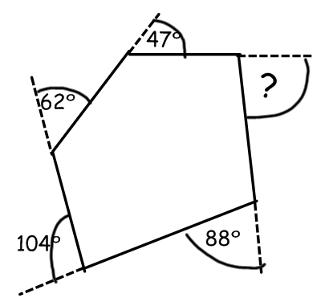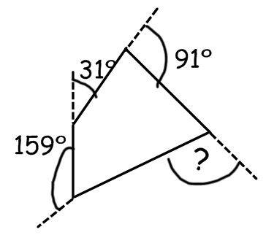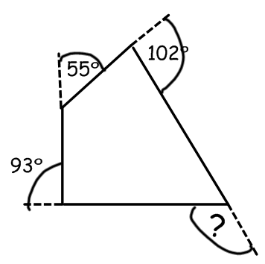a) b) c)

1. Use this formula to work out the sum of the interior angles for the following shapes:

**Sum of interior angles = (n – 2) x 180 where n is number of sides**

a) A Pentagon (5 sides) b) A Heptagon (7 sides) c) An Octagon (8 sides)

d) A Decagon (10 sides) e) A Dodecahedron (12 sides)