1. What is meant by the term reversible reactions?

……………………………………………………………………………………………………………………………………………………………………………………………………………………………………………………………………………………………………………………………………………....[1]

1. What is the correct symbol to show a reversible reaction?

….…………………………………………………………………………………………………………………………………………………………….....[1]

1. (a) Explain the dehydration of hydrated copper (II) sulfate.

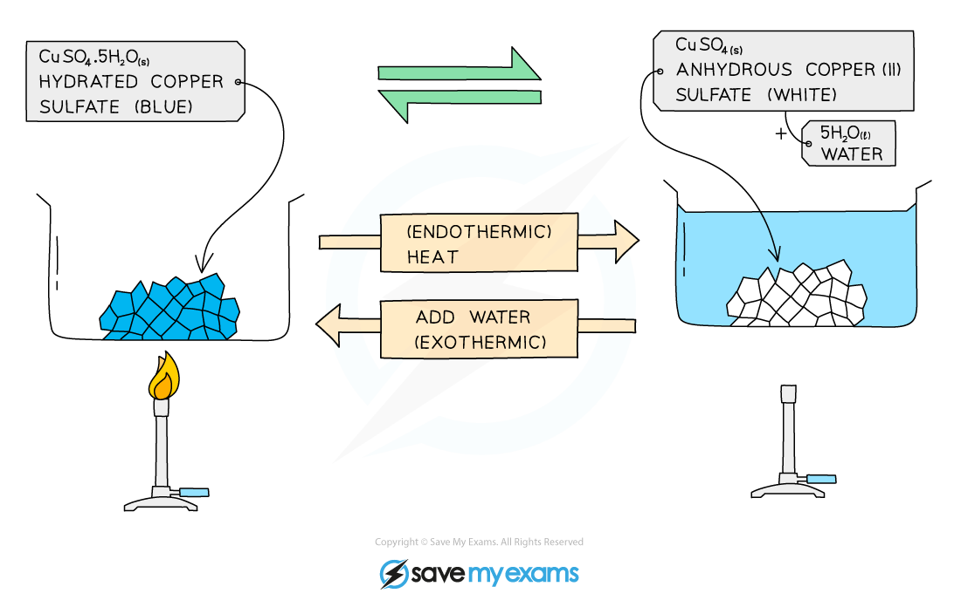

…………………………………………………………………………………………………………………………………………………………………………

…………………………………………………………………………………………………………………………………………………………………………

……………………………………………………………………………………………………………………………………………………………………………………………………………………………………………………………………………………………………………………………………………....[3]

(b) Write the equation of the reversible reaction.

…………………………………………………………………………………………………………………………………………………………….………[1]

1. Explain the dehydration of hydrated cobalt (II) cholride.

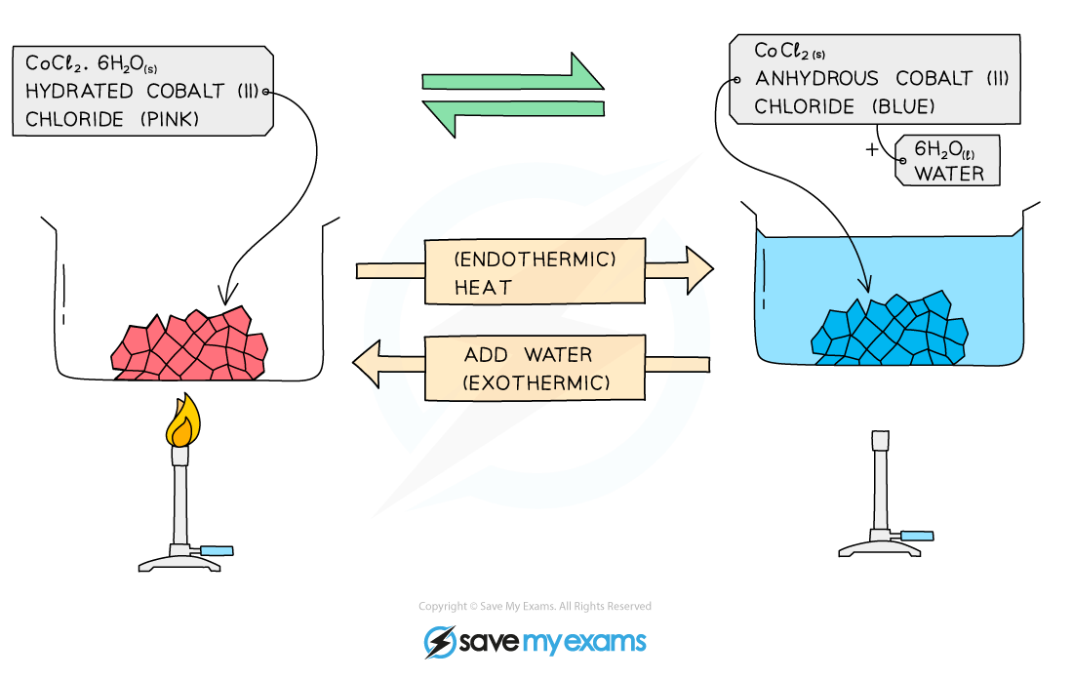

…………………………………………………………………………………………………………………………………………………………………………

…………………………………………………………………………………………………………………………………………………………………………

……………………………………………………………………………………………………………………………………………………………………………………………………………………………………………………………………………………………………………………………………………....[3]

(b) Write the equation of the reversible reaction.

…………………………………………………………………………………………………………………………………………………………….………[1]

[TOTAL: 10 MARKS]