**ASSIGNMENT-3**

**PHYSICAL SAFETY & E-SAFETY (MARKING SCHEME)**

1. **[6]**

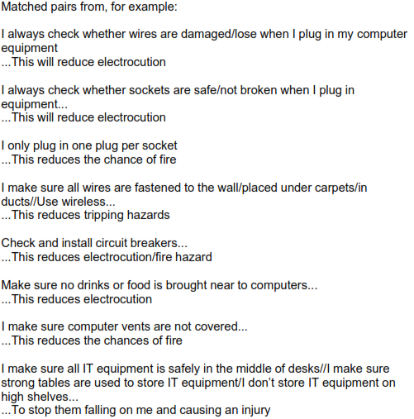

1. **Any two matched pairs [4]**

