Question | Answer | Marks
1(a) | − 5  − 32  − 26  − 171 | 4
1(b)(i) | − 00100101 | 1
1(b)(ii) | − 00011011 | 1
1(c)(i) | Any one from:  − To represent HTML colour codes  − In error messages | 1
1(c)(ii) | Any one from:  − Assembly code/language  − Memory address locations  − In error messages  − Memory dump | 1
2 | Any three from:  − Password  − Add a biometric device to the laptop // set biometric password  − Use two-step verification // Use two factor authentication  − Physically lock the laptop away in a secure cupboard // Taking laptop with him at all times | 3
3(a) | • Low-level language | 1
3(b) | • Assembler | 1
3(c) | Any two from:  • He can directly access the hardware  • He can use special machine-dependent instructions  • There is no need for the program to be portable  • Smaller file size // takes up less storage space  • More efficient use of memory  • Programs will be more time efficient when running | 2
3(d) | Any two from:  • Programs are not portable  • It is complex to learn  • Difficult to debug | 2
4(a) | One mark for identification of the method (max 2), one mark for describing how the method could be used  • Phishing  • A legitimate looking email is sent to her, asking her to click a link  • … this takes her to a fake website where she enters her bank details  • Pharming  • She accidentally downloads malicious software onto her computer  • … this redirects her legitimate website requests to a fake website where she enters her bank details  • Hacking  • A person gains unauthorised access to her computer  • .. they steal/view a data file that contains her bank details  • Spyware  • Records the key presses on her computer  • … this data is analysed for patterns and her bank details are identified | 4
4(b) | Any five from:  • Web browser sends request to web server  • … to view the digital certificate  • Web server sends the digital certificate to the web browser  • Web browser checks the certificate for authenticity  • If certificate is authentic a secure connection is created  • Any data sent is encrypted  • If certificate is not authentic the connection is rejected  • Uses a protocol such as SSL/TLS | 5
4(c) | Any two from:  • A (small) text files  • … that is stored by the browser  • … sent between web server and browser when user visits the website  Any two from e.g.:  • To track users browsing habits  • To store personal details  • To tailor web page to user's presentation requirements  • To store items in a virtual shopping cart  • To tailor adverts to a user | 4

Question | Answer | Marks
5 | Statement true (✓) false (✓)  47KB is larger than 10MB. ✓  250bytes is smaller than 0.5MB. ✓  50GB is larger than 100MB. ✓  1TB is smaller than 4GB. ✓  1 mark per correct tick | 4
6 | Statement True False  Data is transmitted in one direction only, one bit at a time. ✓  Data is transmitted in both directions, multiple bits at a time. ✓  Data is transmitted in one direction only, multiple bits at a time. ✓  Data is transmitted in both directions, but only one direction at a time. Data is transmitted one bit at a time. ✓  Data is transmitted in both directions, but only one direction at a time. Data is transmitted multiple bits at a time. ✓ | 5
7(a) | 1 mark per correct tick  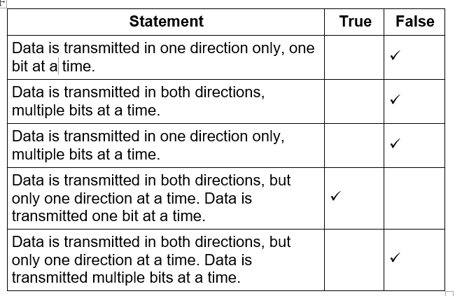 | 3
7(b) | Four from:  - Uses acknowledgement and time out  - Check performed on received data // error is detected by e.g. parity check, check sum  - If error detected, request sent to resend data // negative acknowledgment is used  - If no acknowledgement is sent that data is received // positive acknowledgement is used  - Data is resent / Resend request repeated, till data is resent correctly …  … or request times out // limit is reached | 4
8 | 1 mark for appropriate device name and 1 further mark for appropriate purpose.  Input devices Two from:  - Keypad / Keyboard …  - … e.g. to allow customer to input the quantity of an item  - Touchscreen …  - … e.g. to allow a customer to select a payment method  - Barcode scanner / Barcode reader …  - … e.g. to allow a customer to scan in their shopping  - Card reader // Cash deposit / intake …  - … e.g. to allow a customer to pay for their shopping  - Weighing scales …  - … e.g. to allow a customer to weigh fresh produce  Output devices One from:  - Display / Touchscreen …  - … e.g. to allow a customer to see the running total of their shopping  - Speaker …  - … e.g. to give audio instructions to a customer about how to use the self-checkout  - Printer …  … e.g. to print a receipt for the customer | 6
9(a) | 1 mark for appropriate sensor and 1 further mark for appropriate use.  Two from:  - Gas (sensor) …  - … e.g. to measure the levels of oxygen/carbon dioxide / nitrogen in the factory to make sure they are not too high / low  - Temperature (sensor) …  - … e.g. to measure the temperature of the chemicals to make sure it is not too high/low  - Motion / Infra-red (sensor) …  - … e.g. to detect any persons in an unauthorised area of the factory  - Pressure (sensor) …  - … e.g. to measure the pressure of chemicals flowing through pipes to check that level are not too high / low  - pH (sensor) …  - … to measure the pH to make sure the acidity / alkalinity of the chemicals is correct  - Light (sensor) …  … to measure the level of light to make sure it remains at a constant level for the chemical process | 4
9(b) | Five from:  • Sensors send signals to microprocessor  • Analogue signals are converted to digital (using ADC)  • Microprocessor compares value to stored value …  • … If out of range / matches stored values …  • … signal sent to alert workers (e.g. sound alarm)  • … microprocessor send signal to cause an action to occur e.g. cool a process down, heat a process up, add a chemical  • … no action taken  • Output/record readings  • Monitoring is continuous | 5
10(a) | Two from:  • Smaller file to transmit  • The file is transmitted quicker  • Uses / requires less bandwidth | 2
10(b)(i) | • Lossless (compression) …  • … It is important the code must be (exactly) the same as the original file  • … If it does not match the original file it will not work | 3
10(b)(ii) | • Lossy (compression) …  • … It would make the file smaller than lossless compression / the file would stream faster than lossless compression  • … The quality of the video can be reduced but it can still be viewed | 3
11(a) | One mark for each correct stage of working (max 2):  • 512 x 512  • 262 144 * 2 // multiplied by 16 and divided by 8  • 524 288/1024 | 3
12(a)(i) | An IP address that has numerical values separated by dots that follows the format with a max value of 255 in any xxx xxx.xxx.xxx.xxx  Example: 10.245.3.99 | 1
12(a)(ii) | Any two from:  • 128-bit // 16 bytes  • Hexadecimal  • Separated by colons  • Characters in groups of 4  • Has 8 groups of characters  • Double colons can be used for sets of (consecutive) zeros (only once) | 2

