Cumulative Frequency Codebreaker
A | B | C | D | E | F | G | H | I | J | K | L | M
$$20$$ | $$32$$ | $$27$$ | $$78$$ | $$50$$ | $$92$$ | $$52$$ | $$103$$ | $$47$$ | $$40$$ | $$16$$ | $$12$$ | $$100$$
N | O | P | Q | R | S | T | U | V | W | X | Y | Z
$$148$$ | $$60$$ | $$150$$ | $$30$$ | $$75$$ | $$8$$ | $$25$$ | $$65$$ | $$72$$ | $$5$$ | $$83$$ | $$120$$ | $$2$$

Use the cumulative frequency graph to answer the questions, link your answers to the table above and unjumble the letters to reveal what the person stuck between two buildings was named:
The cumulative frequency graphs below shows the ages of shoppers one Saturday afternoon: | The cumulative frequency graph below shows the times runners achieved in a race: | The cumulative frequency graph shows the ages of workers at a factory:
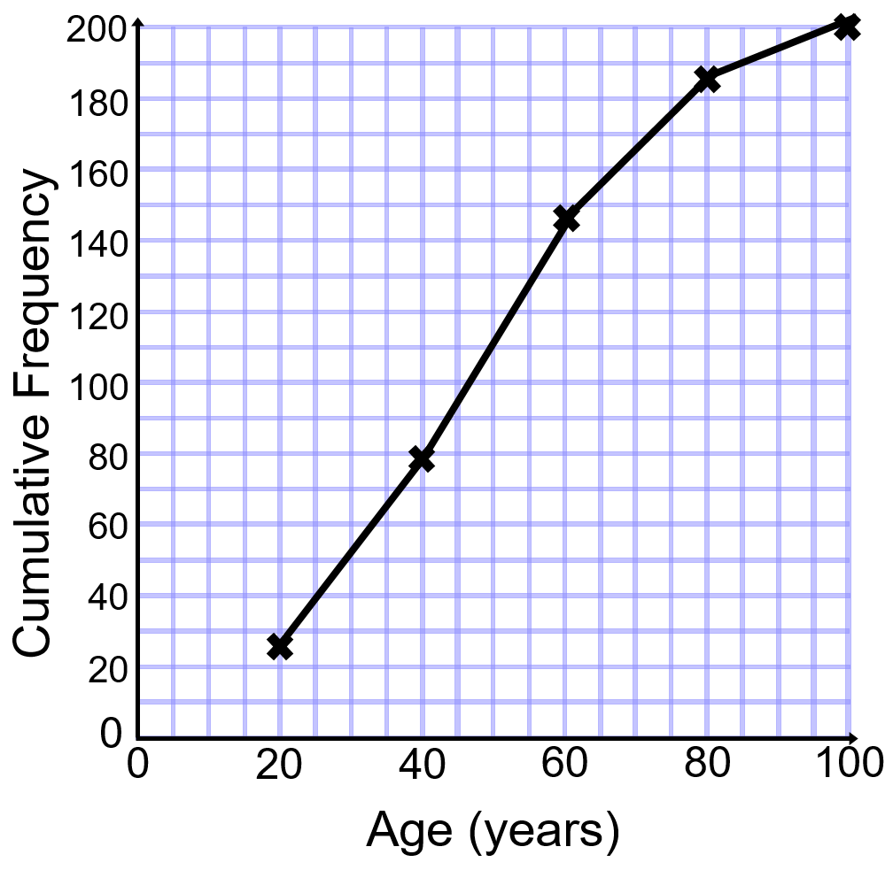 | 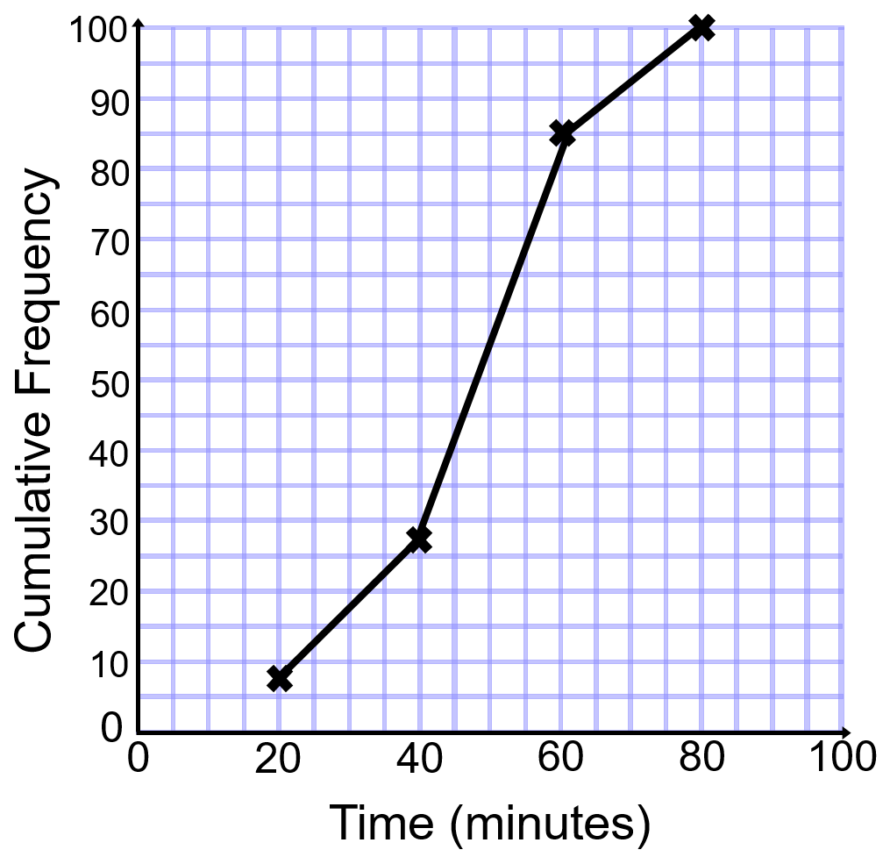 | 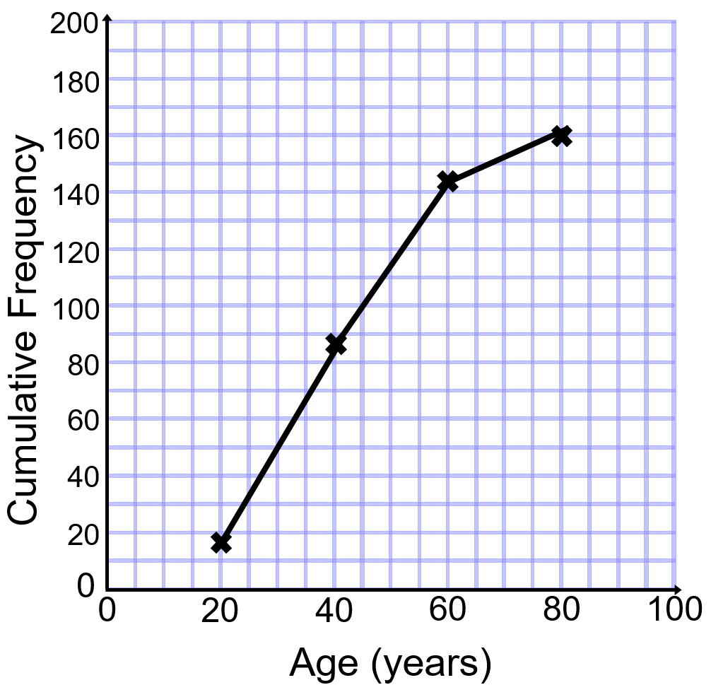
Find the median age of shoppers. | Find the inter-quartile range of the times | How many of the workers are older than $65$?

