1. Complete the question using an appropriate item from the list given.

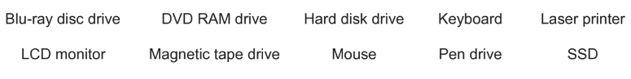

1. Identify two output devices from the list. [2]

……………………………………………………………………………………………………………………………………………………………………………………………………………………

1. Complete the question using an appropriate item from the list given.

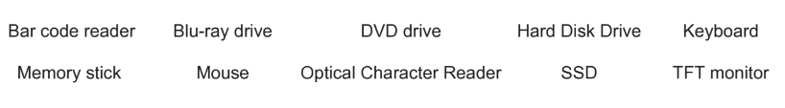

1. Identify two solid state storage devices from the list. [2]

…………………………………………………………………………………………………………...…………………………………………………………………………………………………………..

1. Describe four benefits of using 3D printers. [4]

1……………………………………………………………………………………………………………..………………………………….……………………………………………………………………………

2……………………………………………………………………………………………………………...

……………………………………………………………………………………………………………….

3……………………………………………………………………………………………………………...

……………………………………………………………………………………………………………….4……………………………………………………………………………………………………………...

……………………………………………………………………………………………………………….

1. This diagram shows a smartphone.

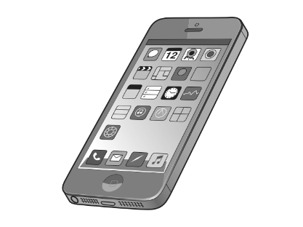

1. Name three input devices found on a smartphone. [3]

1…………………………………………………………………………………………………………2…………………………………………………………………………………………………………3………………………………………………………………………………………………………….

1. Name three output devices found in a smartphone. [3]

1…………………………………………………………………………………………………………2…………………………………………………………………………………………………………3………………………………………………………………………………………………………….

1. A company is purchasing a new printer. A choice has to be made between using a laser printer or a dot matrix printer.

Discuss the advantages and disadvantages of using dot matrix printers rather than laser printers. [6]

…………………………………………………………………………………………………………………………………………………….…………………………………………………………………………………………………………………………………………………….…………………………………………………………………………………………………………………………………………………….…………………………………………………………………………………………………………………………………………………….…………………………………………………………………………

……………………………………………………………………………………………………………………………………………….…………………………………………………………………………………………………………………………………………………….…………………………………………………………………………………………………………………………………………………….…………………………………………………………………………………………………………………………………………………….…………………………………………………………………………………………………………………………………………………….…………………………………………………………………………………………………………………………………………………….……………………………………………………………………………………………………………………