Clumsy Clive On Inequalities - Answers
Clive is tackling his inequalities homework and knows that he’s made mistakes somewhere.
Can you spot and correct the mistakes Clive has made?
Can you explain what mistakes Clive has made, and maybe give him some tips so that he (hopefully) doesn’t make them again?
Question 1:
List the integers represented by the number line below:
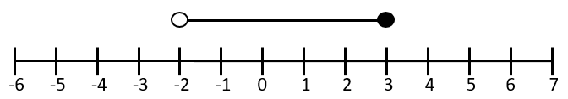
Clive’s answer: | Your answer:
The circles are above $-2$ and $3$ with the line in-between.  Answer:  $$-2,-1,0,1,2,3$$ | The circles are above $-2$ and $3$ with the line in-between.  The circle above $-2$ is not solid.  Answer:  $$-1,0,1,2,3$$
What mistake has Clive made?
He has not considered that the left-hand circle is not solid which means that you don’t include that integer.

Question 2:
Solve the following inequality:
$$4x+3>27$$
Clive’s answer: | Your answer:
Solve it like an equation:  $$4x+3=27$$  $$4x=24$$  Answer:  $$x=6$$ | Solve it like an equation:  $$4x+3>27$$  $$4x>24$$  Answer:  $$x>6$$
What mistake has Clive made?
You can’t swap the inequality sign for the answer as the inequality means that the solution can be anything greater than $6$, not just $6$.

Question 3:
List the integers represented by this inequality:
$$-6≤2x-3<5$$
Clive’s answer: | Your answer:
$$-6≤2x-3<5$$  $$-9≤2x<8$$  $$-4.5≤x<4$$  Answer:  $$-4,-3,-2,-1,0,1,2,3$$ | $$-6≤2x-3<5$$  $$-3≤2x<8$$  $$-1.5≤x<4$$  Answer:  $$-1,0,1,2,3$$
What mistake has Clive made?
Instead of adding $3$ to $-6$ he has subtracted $3$.

Question 4:
On the grid below shade the region given by the inequalities:
$$y≥-1$$
$$x≥2$$
$$x+y≤5$$
Clive’s answer: | Your answer:
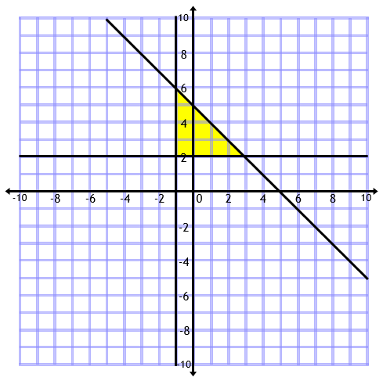 | 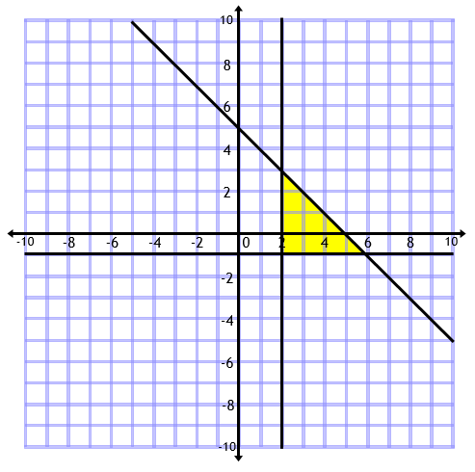
What mistake has Clive made?
He has got the vertical and horizontal lines confused.
He has $y=-1$ as vertical and $x=2$ as horizontal.

