Clumsy Clive On Inequalities
Clive is tackling his inequalities homework and knows that he’s made mistakes somewhere.
Can you spot and correct the mistakes Clive has made?
Can you explain what mistakes Clive has made, and maybe give him some tips so that he (hopefully) doesn’t make them again?
Question 1:
List the integers represented by the number line below:
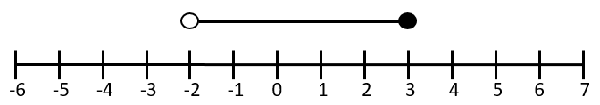
Clive’s answer: | Your answer:
The circles are above $-2$ and $3$ with the line in-between.
Answer:
$$-2,-1,0,1,2,3$$

What mistake has Clive made?

Question 2:
Solve the following inequality:
$$4x+3>27$$
Clive’s answer: | Your answer:
Solve it like an equation:
$$4x+3=27$$
$$4x=24$$
Answer:
$$x=6$$

What mistake has Clive made?

Question 3:
List the integers represented by this inequality:
$$-6≤2x-3<5$$
Clive’s answer: | Your answer:
$$-6≤2x-3<5$$
$$-9≤2x<8$$
$$-4.5≤x<4$$
Answer:
$$-4,-3,-2,-1,0,1,2,3$$

What mistake has Clive made?

Question 4:
On the grid below shade the region given by the inequalities:
$$y≥-1$$
$$x≥2$$
$$x+y≤5$$
Clive’s answer: | Your answer:
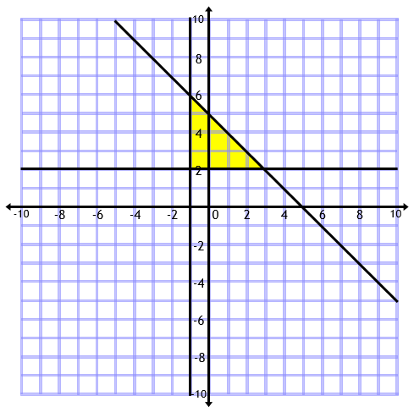 | 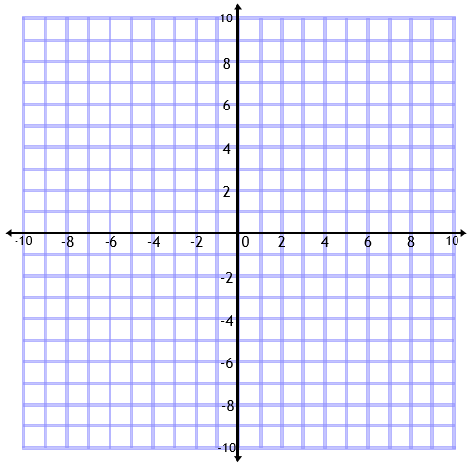
What mistake has Clive made?

