1. On the grid, draw the straight lines and shade the region that satisfies the following inequalities:

𝑦 ≻ 4𝑥 − 3

𝑦 < 6

𝑥 ≻ 0

Label the region R.

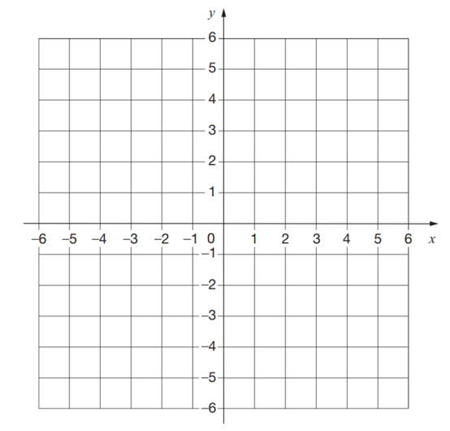 (3)

2. Show, by shading on the grid, the defined by *y* ≥ –1. Label your region **R**. (2)

