1) Complete the encryption for the following message using the Caesar cipher and a key of 3

* 'New pet'
* ‘TNG
* ‘Role Model’
* ‘Qatar’

A B C D E F G H I J K L M N O P Q R S T U V W X Y Z

|  |  |  |  |  |  |  |  |
| --- | --- | --- | --- | --- | --- | --- | --- |
| Plain Text | N | E | W |  | P | E | T |
| Cipher Text |  |  |  |  |  |  |  |

|  |  |  |  |
| --- | --- | --- | --- |
| Plain Text | T | N | G |
| Cipher Text |  |  |  |

|  |  |  |  |  |  |  |  |  |  |  |
| --- | --- | --- | --- | --- | --- | --- | --- | --- | --- | --- |
| Plain Text | R | O | L | E |  | M | O | D | E | L |
| Cipher Text |  |  |  |  |  |  |  |  |  |  |

|  |  |  |  |  |
| --- | --- | --- | --- | --- |
| Plain Text | D | O | H | A |
| Cipher Text |  |  |  |  |

2) Decrypt the following using the pigeon cipher. Refer to the below symbols for each alphabet.

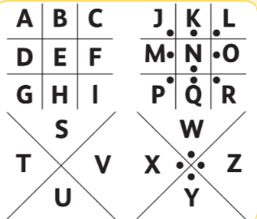

a) Which pigeon symbols will be used to represent the following letters of alphabet?

|  |  |  |  |  |  |
| --- | --- | --- | --- | --- | --- |
| C | G | I | Z | S | O |
|  |  |  |  |  |  |

b) Encrypt and decrypt the statements by referring to the above image.

* + It is sunny.

_______________________________________________________________

_______________________________________________________________

* + Computer Science

_______________________________________________________________

_______________________________________________________________

* + 

________________________________________________________________

________________________________________________________________

* + 

________________________________________________________________

________________________________________________________________