Worksheet 10 (Theory 3)
Topic: Output devices

Question | Answer | Marks
1a | 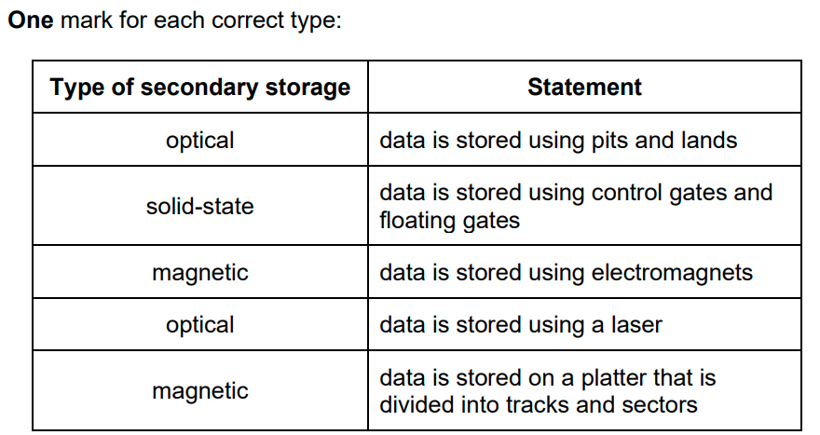 | 5
1 b | 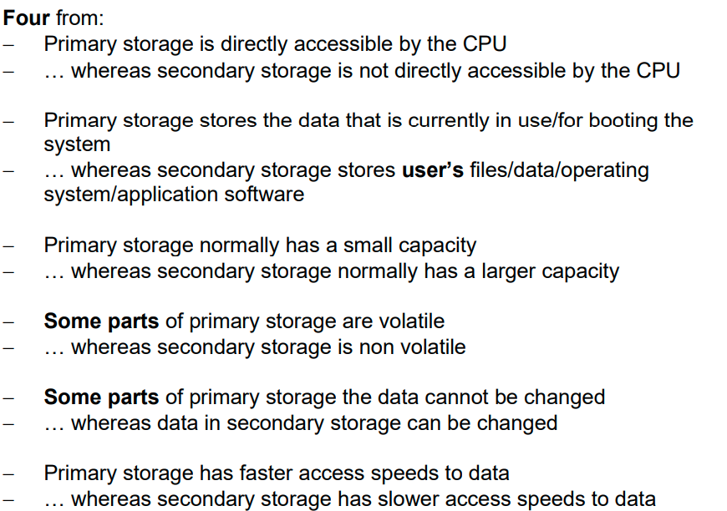 | 4
2 | C | 1

