**Worksheet 12 (Theory 4)**

**Topic: Storage Device**

Q1

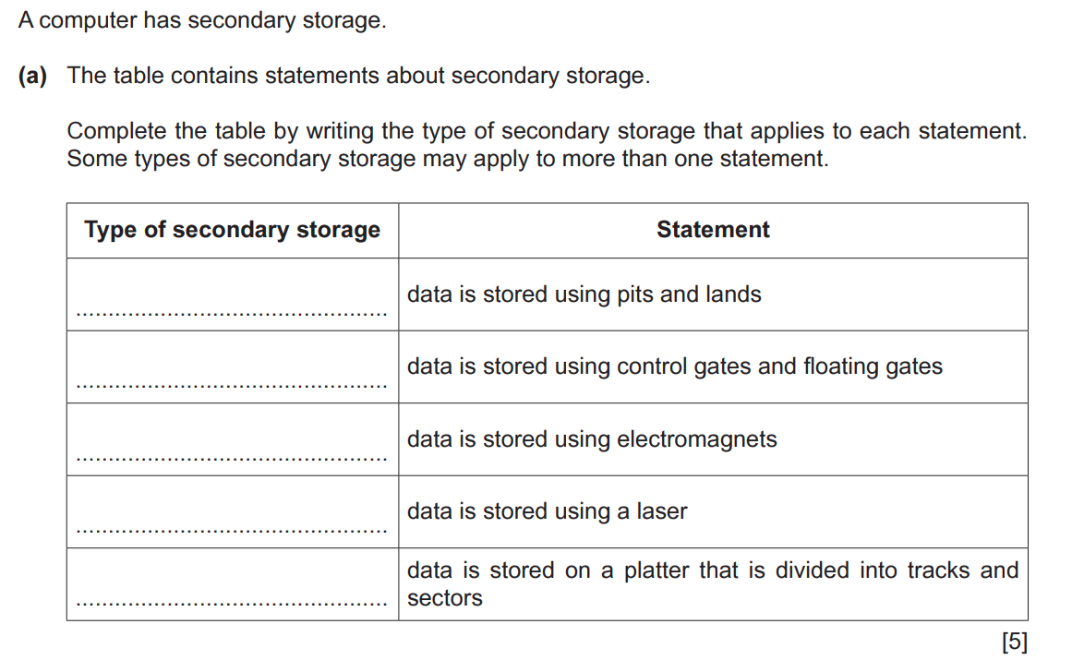

Q2.

