1. **Fill in the blanks:**

**Select text Calibri Font colour Highlight Font**

1. __________________ dialog box can change font size, font name, style and colour.
2. The default font name in MS Word is________________________.
3. __________________ can be changed to emphasise specific text.
4. _________________ button is used to highlight important text
5. ______________________ or word is required when you want to move it to some other place or make copy of it.
6. **Maria has prepared a project report on ‘Biofriendly Chemicals’. She wanted to make her project report look impressive. What feature will she choose to bring the following changes in her report.**
7. Make the text aligned on both sides_______________________________________
8. Make a text a little darker_______________________________________________
9. Underline the text_____________________________________________________
10. Make the text a little slanting_____________________________________________
11. Write the heading in the center____________________________________________
12. **Identify the icons:**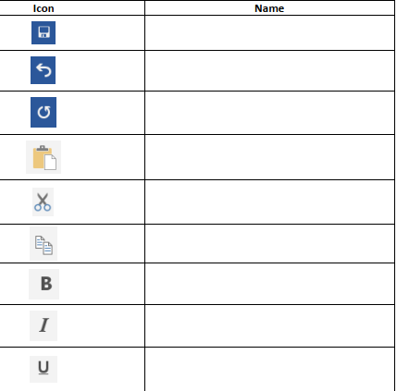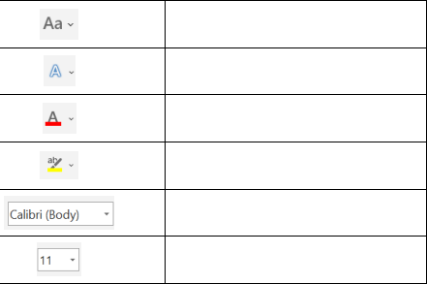
13. **Multiple Choice Questions**
14. Selecting text means, selecting?
    1. a word
    2. an entire sentence
    3. whole document
    4. any of the above
15. Which key should be pressed to start a new paragraph in MS-Word?
    1. Down Cursor Key
    2. Enter Key
    3. Shift + Enter
    4. Ctrl + Enter
16. Which of these toolbars allows changing of Fonts and their sizes?
    1. Standard
    2. Formatting
    3. Print Preview
    4. None of these
17. What is the extension of files created in Ms-Word?
18. dot
19. doc
20. dom
21. txt
22. Which of the following is not a font style?
23. Bold
24. Italics
25. Regular
26. Superscript
27. Which of the following is the correct sequence of steps to open MS-Word?
28. Start→Programs→Accessories→MS-Word
29. Start→Programs→MS-Office→MS-Word
30. Start→Programs→Accessories→MS-Office
31. Start→Programs→Documents→MS-Word
32. How do you select the whole text of the document in MS-Word?
33. Press Ctrl + X
34. Press Ctrl + Z
35. Press Ctrl + N
36. Press Ctrl + A
37. Which keys are pressed to copy text from the document?
38. Ctrl + X
39. Ctrl + C
40. Ctrl + V
41. Ctrl + A
42. What is the given toolbar called?

1. Standard tool bar
2. Menu bar
3. Formatting tool bar
4. Title bar
5. Which of these formatting options will you use for changing the font size of the text?

|  |  |
| --- | --- |
|  |  |
|  |  |
|  |  |
|  |  |