**REVISION PAPER**

1 (a). Hexadecimal values can be used to represent denary values.

Convert these four hexadecimal values into denary values.

05......................................................

20......................................................

1A......................................................

AB...................................................... [4]

Working space

..................................................................................................................................................

..................................................................................................................................................

..................................................................................................................................................

..................................................................................................................................................

..................................................................................................................................................

(b)Hexadecimal values can also be converted to binary values.

Tick (✓) one box to show the correct 8-bit binary value for each hexadecimal value.

1. Hexadecimal value 25

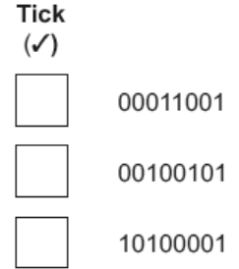 [1]

1. Hexadecimal value 1B

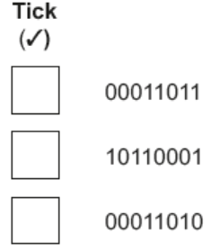 [1]

C (i) Give one way that hexadecimal is used in website development.

.................................................................................................................................... [1]

1. Give one way that hexadecimal is used in low-level programming.

.................................................................................................................................... [1]

2. Sammi works for a finance company and has a laptop that he uses for his work. He has confidential

data about his customers stored on his laptop. Sammi does not connect the laptop to any networks.

(a) Sammi is concerned about his customers’ confidential data being viewed by other people in his office. One method he uses to prevent others viewing the data is encryption.

Identify three other methods Sammi could use to prevent his customers’ confidential data being viewed.

1...............................................................................................................................................

2…...........................................................................................................................................

3............................................................................................................................................... [3]

3. Cameron writes software for coffee machines. He uses assembly language to write his software.

(a) Tick (3) to show whether assembly language is an example of a high-level language,

a low-level language or machine code.

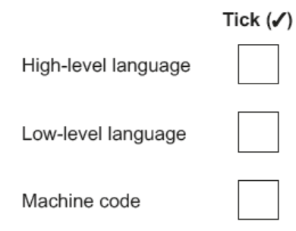 [1]

(b) Identify the translator that is required for assembly language.

............................................................................................................................................ [1]

(c) Give two reasons why Cameron chooses to write the software for the coffee machines in

assembly language.

Reason 1.................................................................................................................................

..................................................................................................................................................

Reason 2.................................................................................................................................

.................................................................................................................................................. [2]

(d) Give two drawbacks of using assembly language to write programs.

Drawback 1...............................................................................................................................

..................................................................................................................................................

Drawback 2...............................................................................................................................

.................................................................................................................................................. [2]

4. Eleanor has a website that she uses to advertise the cakes that she bakes.

She thinks her bank details were stolen electronically, while she was using the Internet.

1. Identify and describe two methods that could have been used to steal Eleanor’s bank details electronically.

Method 1..................................................................................................................................

..................................................................................................................................................

..................................................................................................................................................

..................................................................................................................................................

..................................................................................................................................................

..................................................................................................................................................

Method 2..................................................................................................................................

..................................................................................................................................................

..................................................................................................................................................

..................................................................................................................................................

..................................................................................................................................................

............................................................................................................................................... [4]

(b) Eleanor uses a secure connection to allow customers to buy the cakes from her website.

Describe how the secure connection is created.

..................................................................................................................................................

..................................................................................................................................................

..................................................................................................................................................

..................................................................................................................................................

..................................................................................................................................................

..................................................................................................................................................

..................................................................................................................................................

..................................................................................................................................................

................................................................................................................................................. [5]

(c) Eleanor’s website uses cookies.

Explain what is meant by the term cookies and give two examples of how cookies can be

used.

..................................................................................................................................................

..................................................................................................................................................

..................................................................................................................................................

..................................................................................................................................................

..................................................................................................................................................

..................................................................................................................................................

..................................................................................................................................................

................................................................................................................................................. [4]