1. A database table, APPLIANCE, is used to keep a record of kitchen appliances available for sale.

The following data is stored for each appliance:

• CATEGORY – washer, dishwasher, fridge or freezer

• ECONOMYRATING – A, B, C or D

• MANUFACTURER – Baku or ABC

• PRICE – price in $

• CODE – a unique code allocated by the manufacturer e.g. B982

• STOCK – number in stock.

The database management system uses these data types:

Text Number Currency Boolean

The ECONOMYRATING field and MANUFACTURER field have a data type of text.

(a)Identify the most appropriate data type for each field from the **four** types shown. State the

reason why you chose each data type.

CATEGORY data type ..............................................................................................................

Reason ....................................................................................................................................

..................................................................................................................................................

PRICE data type .......................................................................................................................

Reason ....................................................................................................................................

..................................................................................................................................................

CODE data type .......................................................................................................................

Reason ....................................................................................................................................

..................................................................................................................................................

STOCK data type ......................................................................................................................

Reason .................................................................................................................................... [4]

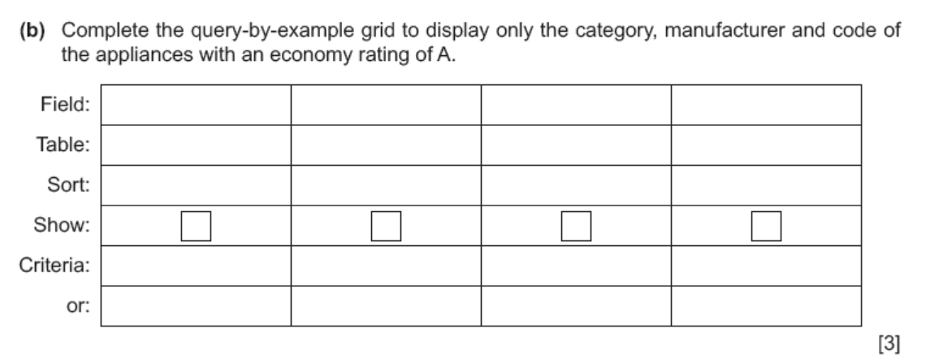

2. A school uses a database table, ASSESS, to keep a record of the internal assessments and the

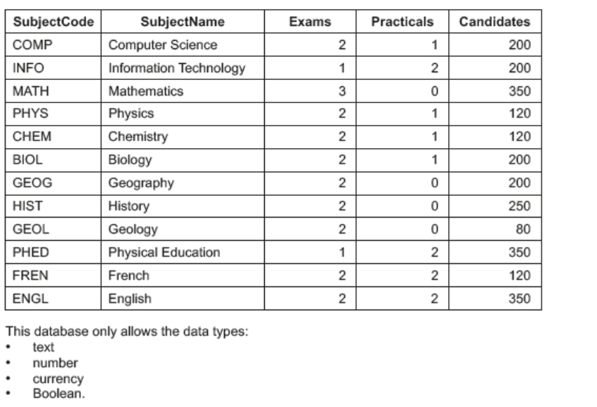 number of candidates for each of the subjects in its curriculum

1. **(i)** State the most appropriate data type for the fields SubjectCode and Exams.

SubjectCode ......................................................................................................................

Exams ...............................................................................................................................[1]

**(ii)** State **one** reason why the Candidates field could **not** be of the Boolean data type.

..........................................................................................................................................

.................................................................................................................................... [1]

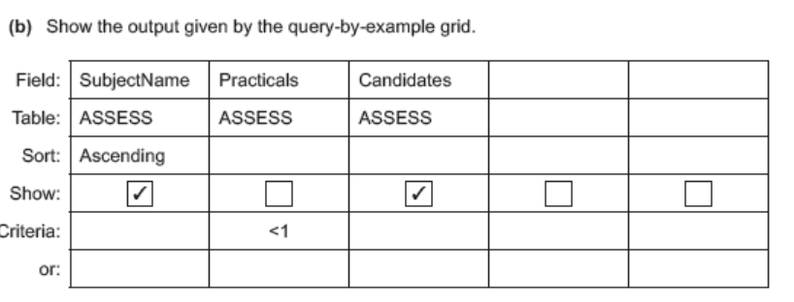

..................................................................................................................................................

..................................................................................................................................................

..................................................................................................................................................

..................................................................................................................................................

..................................................................................................................................................

............................................................................................................................................ [3]

