1. **Choose the correct option.** **[2]**
2. Which network is used to give internet in small area only?

(a) Wi-Fi

(b) Cellular network

(c) None of these

1. Data that is sent over a network is broken into smaller pieces is called__________?  
   (a) IP address

(b) Data packets

(c) None of these

1. **You're traveling overseas and need to stay in touch with your family back home. Which device, a smartphone or a house phone, would be more convenient for making calls and sending messages? Why? [2]**

____________________________________________________________________

____________________________________________________________________

____________________________________________________________________

____________________________________________________________________

____________________________________________________________________

1. **There are four types of equipment found at a cell site. [6]**

**Name these four types of equipment and explain any two of them.**

____________________________________________________________________

____________________________________________________________________

____________________________________________________________________

____________________________________________________________________

____________________________________________________________________

____________________________________________________________________

____________________________________________________________________

____________________________________________________________________

____________________________________________________________________

____________________________________________________________________

1. **Each packet that is sent over the internet includes four essential parts.**

**Name each part that is connected with each part. [4]**

1. _______________________________________________________________
2. _______________________________________________________________
3. _______________________________________________________________
4. _______________________________________________________________
5. **In many places internet has become an important part of everyday life.**

**Any disruption may affect many people in different ways. [3]**

Write down about any two areas that could be affected by internet disruption.

What kind of problem may arise due to internet disruption in these areas?

____________________________________________________________________

____________________________________________________________________

____________________________________________________________________

____________________________________________________________________

____________________________________________________________________

____________________________________________________________________

____________________________________________________________________

____________________________________________________________________

1. **Complete the given algorithm that adds three numbers together entered by the user. This algorithm has four variables. [4]**

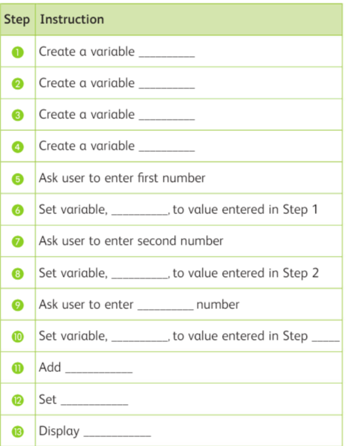

1. **State whether the statements are true or false. [5]**
2. Mobile phones can be used to make phone calls while on a train. ( )
3. All data packets that make up the small email are sent along the same route to the destination computer. ( )
4. An email is usually sent as one complete message. ( )
5. A cell is a place where mobile phones are stored. ( )
6. Mobile devices can access the internet by using wireless signals. ( )