**I. Choose the correct answer. [3]**

|  |  |  |  |  |  |
| --- | --- | --- | --- | --- | --- |
| **Multiple** | **Flowchart** | **Selection** | **Evaluation** | **Digital data** | **Sequence** |

1. **Flowchart** is a diagram to represent an algorithm.
2. A subroutine can be repeated within a computer program or algorithm **multiple** times.
3. Sequence is the programming constructs that decides the order in which instructions are executed in a program.
4. Selection is the programming constructs that decides the path to take when the program runs.
5. Evaluation phase in a project plan checks that the created software meets the user’s requirements.
6. A computer can store, process and communicate digital data.

**II. State whether the following are true or false. [2]**

1. A count-controlled loop executes a specific number of times.

True

1. Condition-controlled loops cannot result in infinite loops.

False

8)User feedback can help improve the design of a program.

False

True

9) Block based programming can be used to create more advanced

programmes than text-based languages.

**III.Match the following. [3]**

|  |  |
| --- | --- |
| 11) Requirement | a) The method by which the user enter data or instructions in to a computer system. |
| 12)Implementation | b) The process of converting analogue data to a digital form. |
| 13) Text based | c) Following a specific set of rules of programming language. |
| 14) Syntax | d) Programming environments are especially important when programming advanced applications. |
| 15)Digitisation | e) Design a prototype solution with the consideration for inputs, outputs, data storage and user interface. |
| 16)Interface | f) Determine the purpose and essentials for the software. |

|  |  |  |  |  |  |
| --- | --- | --- | --- | --- | --- |
| **11)** | **12)** | **13)** | **14)** | **15)** | **16)** |
| **f** | **e** | **d** | **c** | **b** | **a** |

**IV. Answer the following.**

17. Imagine that you are a beginner in programming and is currently learning about different programming environments and the importance of syntax. You encounter various terms and concepts and are trying to understand them better. Help yourself by addressing their queries about syntax in programming.

(a) What does syntax mean in programming [3]



(b) **You do not need to know syntax in which of the two main programming**

 **environments?**

 (c) **Why would someone need to learn and use syntax?**

**V. Answer the following questions. [9]**

18.Our computer science class has been tasked with designing a simple program to help

students practice their multiplication tables. Describe the role of interface when

designing programs. [1]

It is the part of the software that user sees,interacts with,exchanges information and runs instructions.

19. Jordan is a high school student who has been introduced to both text-based and block-based programming in their computer science class. They have some experience using both but are unsure about the advantages and appropriate contexts for each type of programming. Jordan is preparing for a project and needs to decide which programming approach to use.

1. **What are the main differences between text-based and block-based programming? [4]**

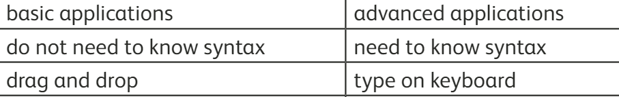

**Uses Text Editor Visual interface**

1. Give two examples each of block based and text-based programming? [2]

Java, python: text-based

Scratch, micro: bit :block based

20. Grade VI students has been assigned a small project where they needs to repeatedly perform tasks such as printing a greeting message and calculating the sum of two numbers. Explain what is meant by subroutine in simple terms. [2]

Subroutine: A block of code that can be called and accessed by a main program or by multiple algorithms.