1. (a) Sex in cats is determined in the same way as in humans.

Complete the diagram bellow to show how sex is determined in cats.

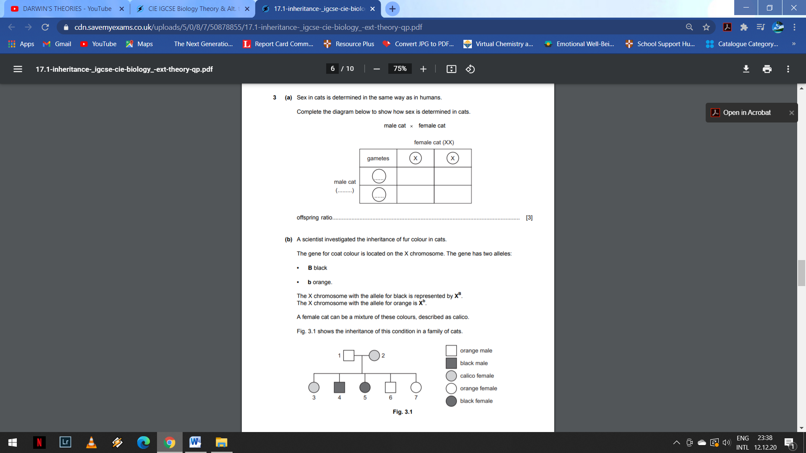

Offspring ratio……………………………………………………………………………………………………………………………………………..[3]

(b) A scientist investigated the inheritance of fur colour in cats.

The gene of coat colour is located on the X chromosomes. The gene has two alleles:

* **B** black
* **b** orange

The X chromosome with the allele for black is represented by XB.

The X chromosome with the allele for orange is represented by Xb.

A female cat can be a mixture of these colours, described as calico.

Fig 1.1 shows thee inheritance of this condition in a family of cats.

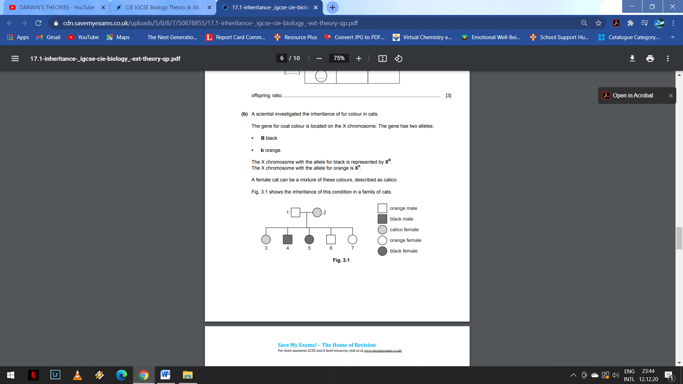

**Fig. 1.1**

States the genotypes of cats 1, 4,and 5 in Fig. 1.1.

cat 1…………………………………………………………………….

Cat 4……………………………………………………………………

Cat 5…………………………………………………………………… [3]

1. (a) A man who is red-green colour-blind marries a woman with normal vision. They have three sons and two daughters. One of the sons is red-green colour-blind. All the other children have normal colour vision. Draw a genetic diagram to suggest an explanation for this. [3]

(b) What is the chance that the couple’s next child will be a colour-blind boy? [1]