Note: The teacher must provide the zigzag book to all students before the lesson.

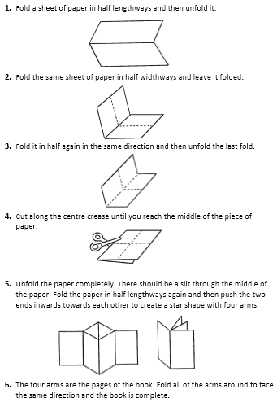**How to Make an 8-page Zigzag Book**