1. Melek wants to estimate the width of a river which has parallel banks. He starts at point A on one bank directly opposite a tree on the other bank. He walks 80 m along the bank to point B and then looks back at the tree. He finds that the line between B and the tree makes an angle of 22° with the bank. Calculate the width of the river.

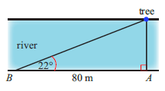

1. Th e top of a vertical cliff is 68 m above sea level. A ship is 175 m from the foot of the cliff. Calculate the angle of elevation of the top of the cliff from the ship.

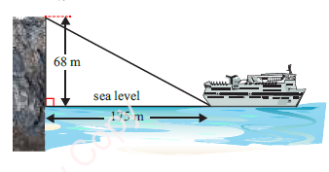

1. A mountain climber walks 380 m along a slope that is inclined at 65° to the horizontal, and then a further 240 m along a slope inclined at 60° to the horizontal. Calculate the total vertical distance through which the climber travels.

