**Task 1:**

1. Open Word Document

2. Apply page border.

3. Apply page colour.

4. Insert an image related to your hobby.

5.Add a Title as MY HOBBY.

6.Apply Bold and Italic on the Title.

5. Write about your hobby (Only one sentence).

6. Save the document as “MY HOBBY”.

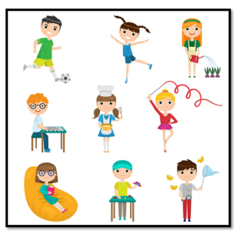

**Task 2:**

Create a program in ScratchJr

* 1. Open ScratchJr
  2. Add a Background
  3. Add any character.
  4. The Character should follow these instruction

|  |  |
| --- | --- |
| Step | Instruction |
| 1 | Start on Green flag |
| 2 | Move left (4) |
| 3 | Jump (2) |
| 4 | Say “HI” |
| 5 | stop |

Run the code after debugging it.

