**Task 1: Code a program for subtracting two numbers by doing the following: [15]**

1.Open a new project named subtraction and delete the forever block. [2]

2.create the variable Num1,Num2 and Result. [1]

3.Set all the three variables to 0 when the simulator is started. [1]

4.When button A is pressed, set the variable Num1 to pick a random number

from 0 to 99. Display number on the screen. [1]

5.From the input group, add the on logo pressed block. [1]

6.Set the variable Num2 to pick a random number from 0 to 50.

Display the number on the screen. [1]

7.From the Input Group, add the on shake block. [1]

8.Set variable Result to subtract Num2 from Num1.Display the answer

on the screen. [1]

9.Test the code. Click start simulator. [1]

10.Click button A. Write the number shown on the display. [1]

11.Click on the logo .Write the number shown on the display. [1]

12.click on the shake button. What is the result of the subtraction of both numbers. [1]

13.On a sheet of paper, subtract the two numbers and compare your

calculation to the result shown on the display. [1]

14.Repeat steps 10 to 13 as many times as you want to subtract different numbers [1]

**Task2:**  **Write the code/execute the algorithms in scratch 3.0. [10]**

**Following are the algorithms for calculate & add.**

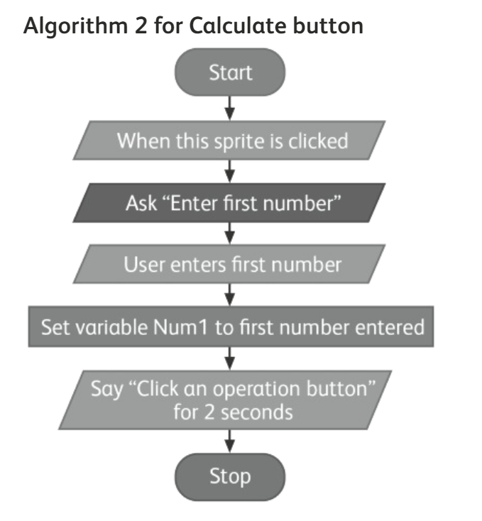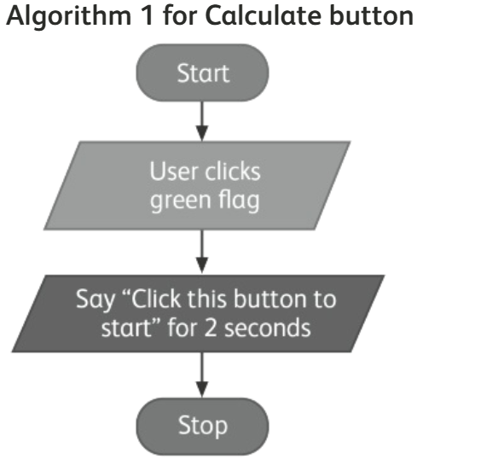

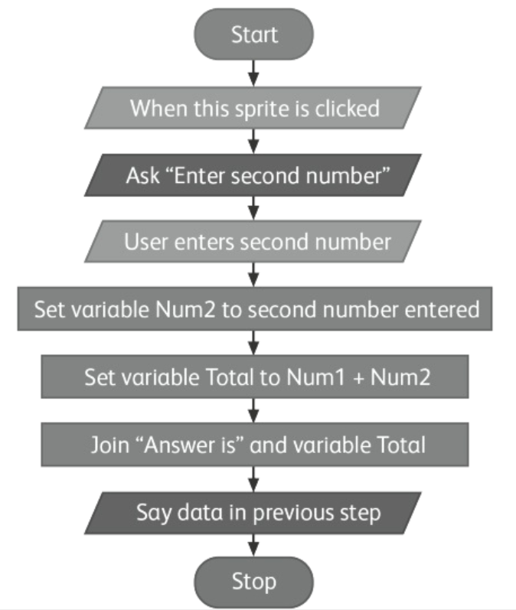

**Task 3: Code a program for entering two numbers and predict the outcome. [5]**

When button A is pressed

1.The variable Num1 and Num2 are set to the value 0. [1]

2.The value of Num1 is then changed by 5 and Num2 is changed by 2. [1]

3.The calculation of Num1 minus Num2 is executed and stored in the variable Result. [1]

4.Steps 2 and 3 are repeated one more time. [1]

5.Then the result is shown on the display. [1]