**4. Algorithm design and problem-solving**

The flowchart represents an algorithm used in a restaurant.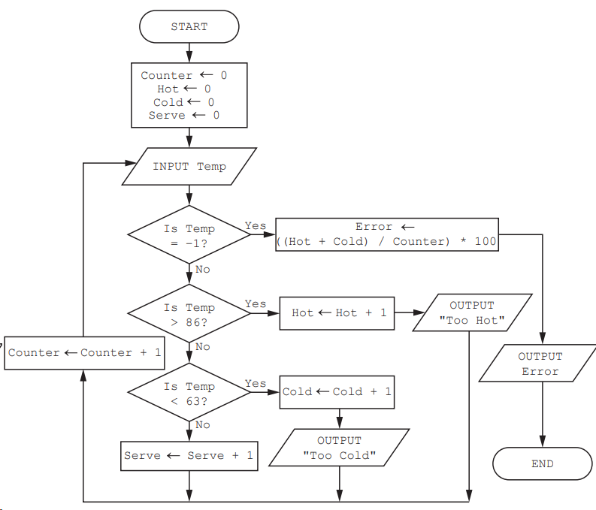

d) State the purpose of the algorithm.

