**Grade 3 Unit 11-page 167 activity – Formatting cells (Data Formats)**

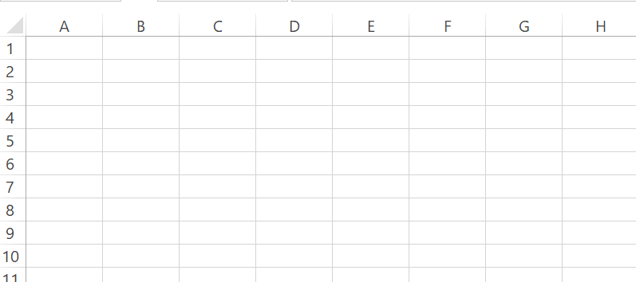

The students will enter the below in the above table.

1. Type ‘Donut order’ in cell A1.
2. Type 5 in cell C2.
3. Type 9/3/2024 in cell in cell B5.
4. Type $20 in cell E8.
5. Type DON105 in cell A7.