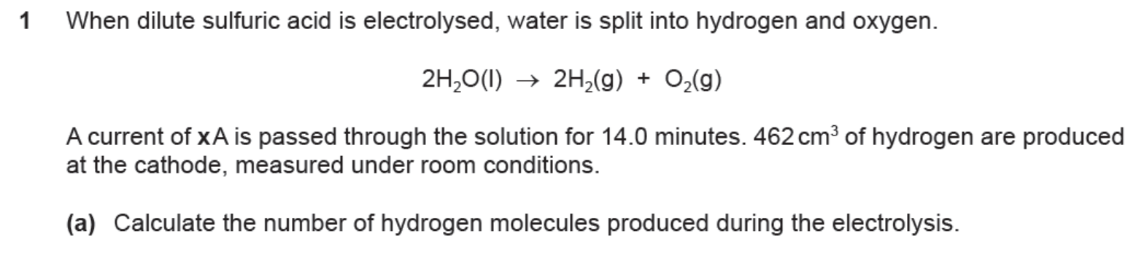







1. **(i)** Define standard electrode potential, *E* o.

A salt bridge is used in an electrochemical cell.

(ii) State the function of the salt bridge. Explain your answer.

**(iii)** Complete the diagram of the apparatus that can be used to measure the *E* o of the

Cr2O72–(aq), H+ (aq)/Cr3+ (aq) electrode against the standard hydrogen electrode.

Your diagram should be fully labelled to identify all apparatus, substances and conditions.

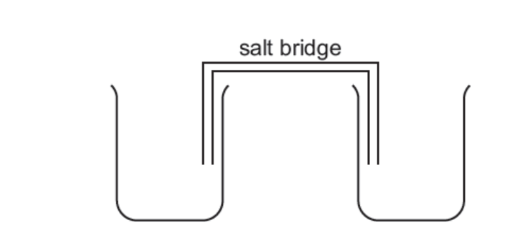

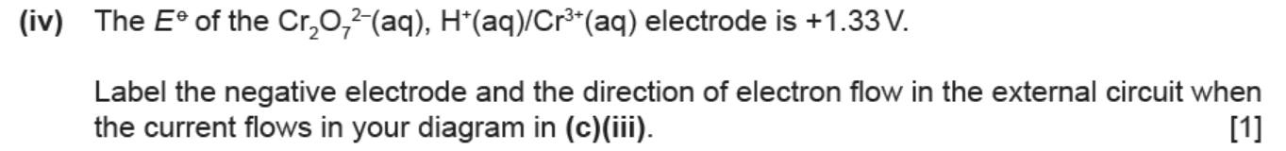

1. Pure water is a very poor conductor of electricity. However, when hydrogen chloride gas is dissolved in water, ions are formed and a current flows during electrolysis



The overall change after electrolysis is that hydrogen chloride gas is converted into hydrogen and

chlorine

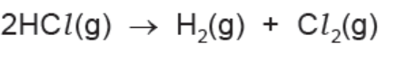

When a current of 3.10 A is passed through the solution for *Y* minutes, 351 cm3 of chlorine are

produced at the anode, measured under room conditions.

1. Calculate the number of chlorine molecules produced during the electrolysis

**(b)** Calculate the total number of electrons transferred to produce this number of chlorine molecules.

(c)Calculate the quantity of charge, in coulombs, of the total number of electrons calculated in **(b)**.

**(d)** Calculate the time, *Y*, in minutes, for which the current flows.

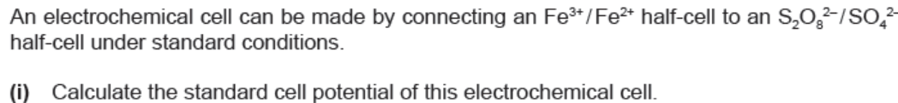





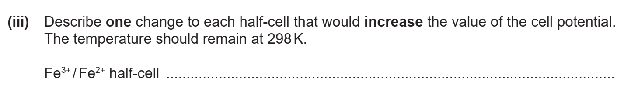

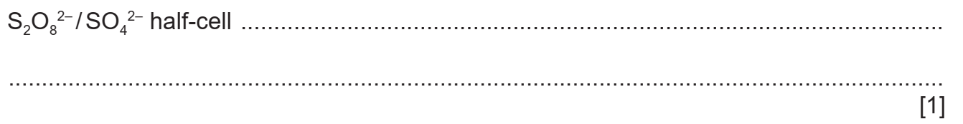

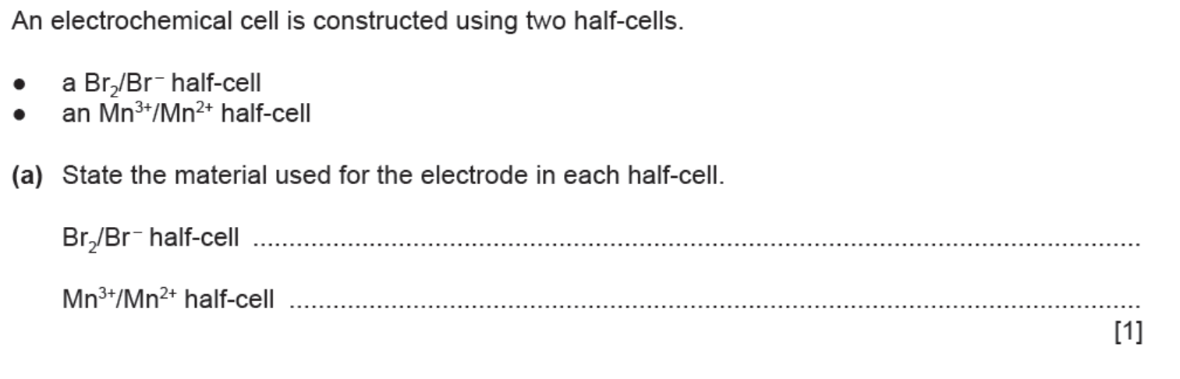

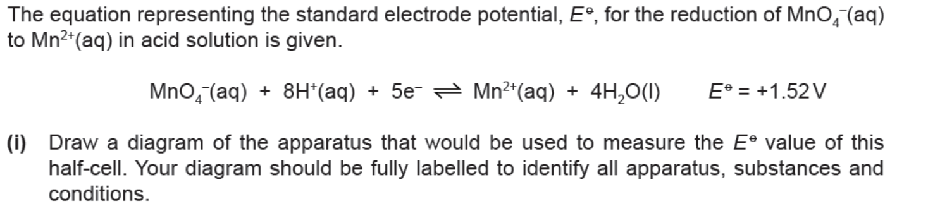

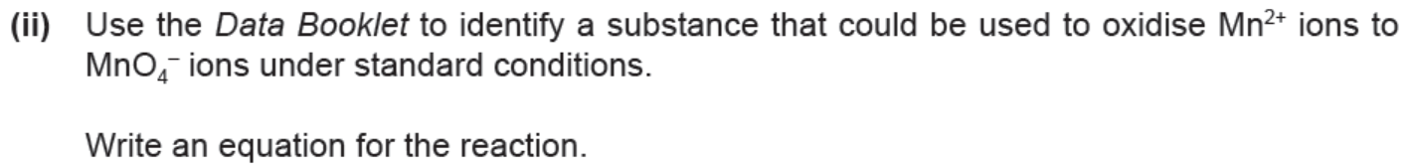



**(b) (i)** Write an equation for the reaction between chlorine and water.

**(ii)** Use standard electrode potential, *E* o, data to calculate the electrode potential of the cell for the following reaction.





