Y2: Summer Non-Fiction: Recounts
Unit 4
SPAG: Present and past progressive verb forms
Teacher Notes

Essential texts
The Velveteen Rabbit, by Margery Williams, ISBN: 978-1405285346

- Prior to Day 1, familiarise yourself and other adults in the classroom with the Grammar Poster (see resources) so that you can support children.
- Think about how you will share the book with children – reading directly, telling the story, listening to a performance or mixing the three. Children may respond quite differently to this book. You may have a sense of that from having introduced it in Unit 2. A Summary is given in the resources, not to be read from directly but so that you could re-tell the story if this will help make it clearer for children. There is also a very good reading of the book on cd, published by Bolinda Audio.
- You will need to make large copies of illustrations from your copy of the book or use those in the separate resource document. The unit refers to the illustrations by William Nicholson included in the edition listed above. The illustrations to be used are:

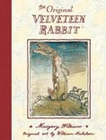 | 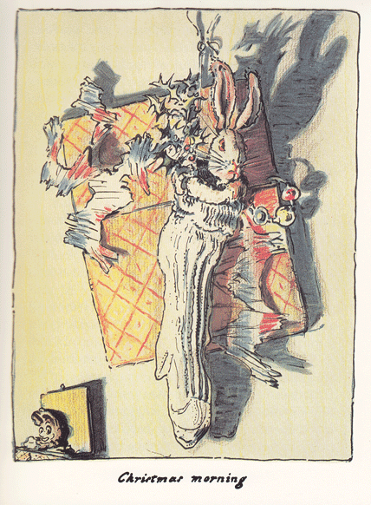 | 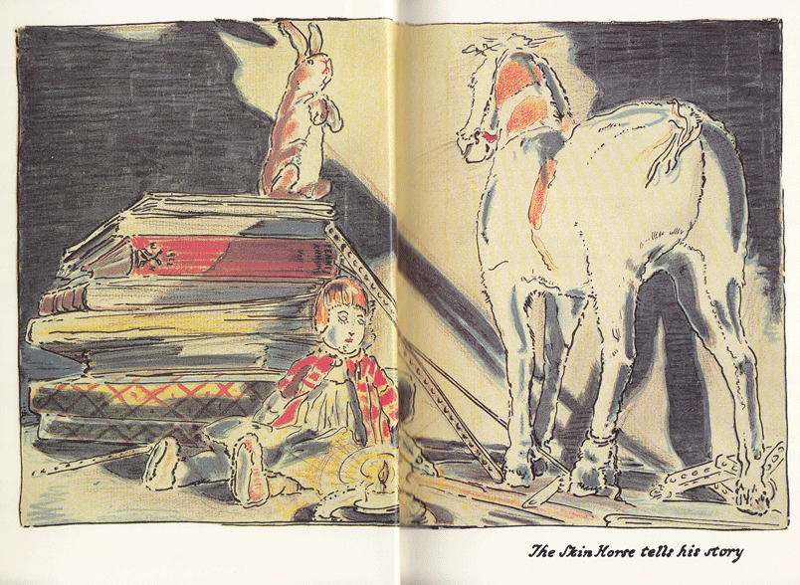 | 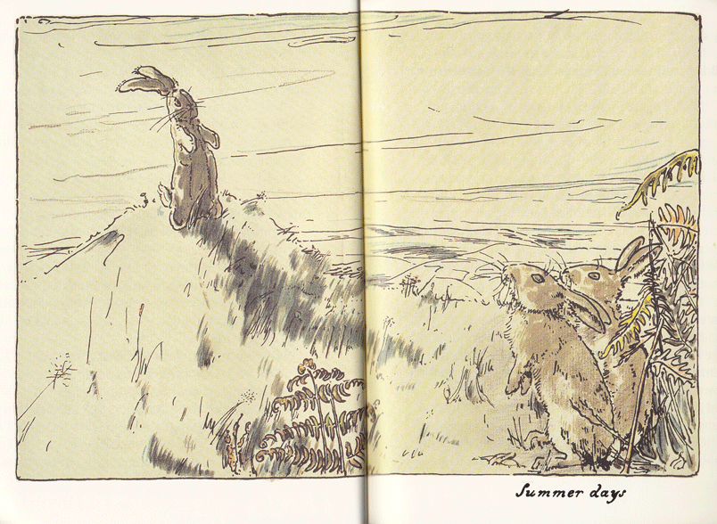 | 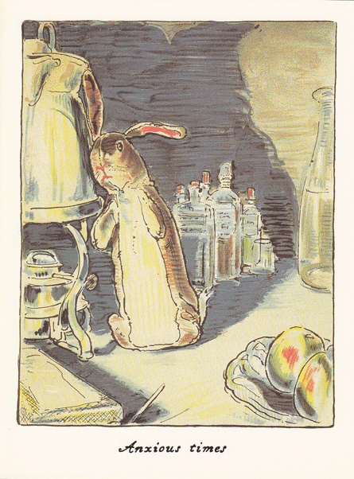 | 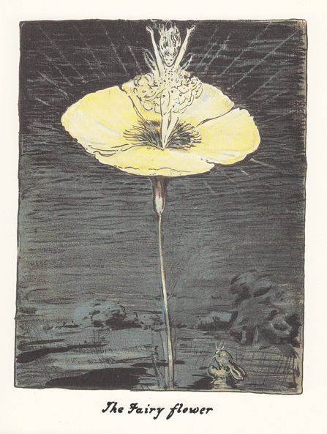
Front Cover | Christmas Morning | Skin Horse tells his story | Summer Days | Anxious Times | The Fairy Flower

SCROLL DOWN FOR TEACHING AND ACTIVITIES

