***STARTER ACTIVITY :***

***Do you think time management is important in a meeting ? State two reasons . [2]***

***What are the challenges that occur during holding a meeting apart from time management .***

***State as may challenges you can think of. [2]***

**DEVELOPMENT ACTIVITY : ( 20 minutes)**

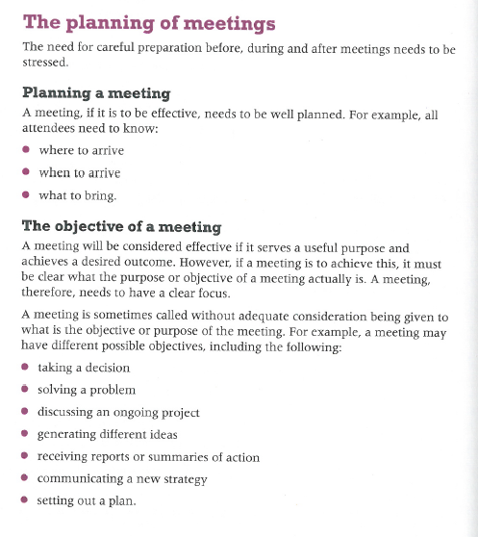

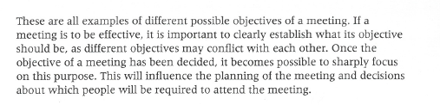

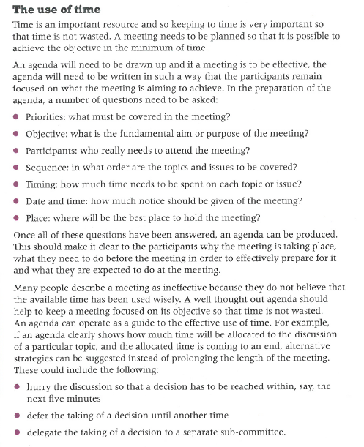

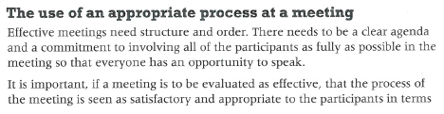

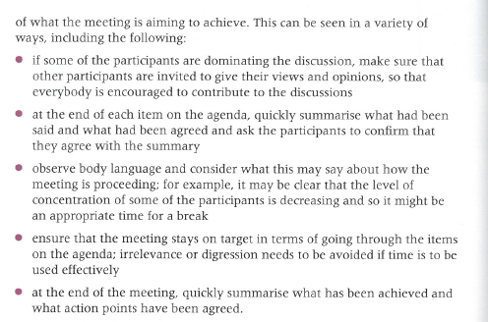

**INDEPENDENT PRACTICE :**

**Q1. Explain why it is important that a meeting is well planned . [6]**

**Q2. Discuss the importance of keeping to time in meetings. [6]**

**MATCH THE FOLLOWING :**

**A B**

What is the importance of holding a meeting ? He records a summary of the

discussion that takes place

during the meeting , especially the

decisions that are taken during

the meeting.

What all are the important points in the He makes sure the meeting stays

Notice of a meeting ? on track and achieves the

desired outcomes.

What is the information that an agenda includes ? the purpose of the meeting and its

expected outcome.

What are the duties of a chairperson ? Training people

What are the duties of a minute taker ? Date , time , venue and duration of

the meeting.