Inequalities on graphs. Shade the regions described by the inequality
1.  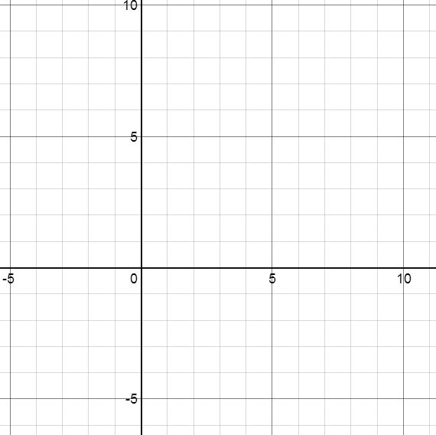  $$x>1$$ | 2.  $$x≤7$$
3. | 4.  $$y<-2$$
$$y≥4$$
5.  $$x≥1 \& y≤4$$ | 6.  $$x≤-1 \& y>-3$$
7.  $$2<x≤8$$ | 8.  $$-3≤y<1$$
9.  $$2<x<4 \& 2<y<4$$ | 10.  $$-1<x≤5 \& -2≤y<5$$
11.  $x<-2, x>4 \& y≥5$ (may be more than one region) | 12.  $$x>-3, y≤-3 \& y≥5$$
13.  $$y≤x$$ | 14.  $$y>x$$
15.  $$y<-x$$ | 16.  $$y≥-x$$
17.  $$y≤x+2$$ | 18.  $$y≥x-4$$

19.  $$x+y≤6$$ | 20.  $$x+y>-3$$
21.  $$2x+y<10$$ | 22.  $$x+2y≤4$$
23.  $$2x+5y>10$$ | 24.  $$y-2x<6$$

