**Formal Formative 1(Practical)-Marking Scheme**

**Question 1:**

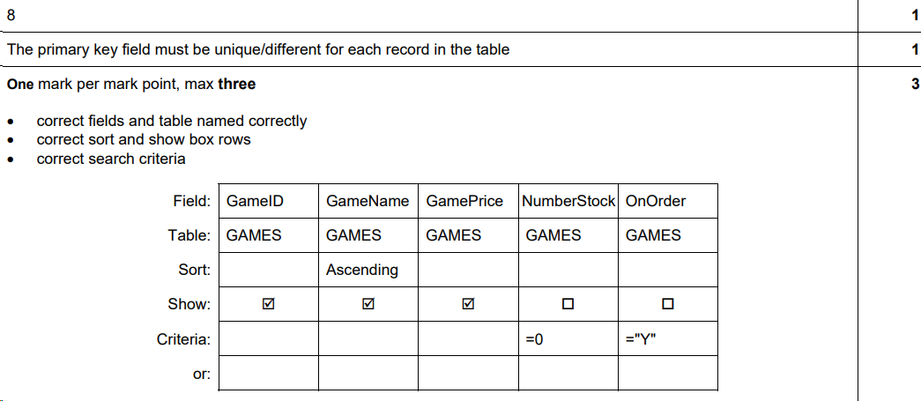

**Question 2:**

**Question 3:**

