1. | Parameter [1]
2. | 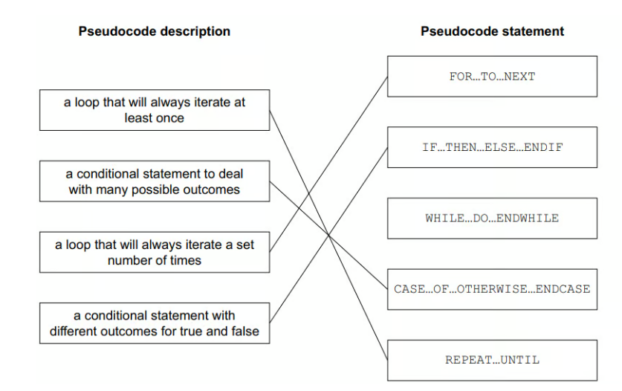 [4]
3. | a) One mark for each correct line.  DECLARE X : STRING  DECLARE Y : INTEGER  DECLARE Z : INTEGER.  [3]
4. | One mark per bullet point  37  Data type name Integer  Data type description (Any) whole number  Cambridge2021  Data type name String  Data type description A group of characters/text  47.86  Data type name Real  Data type description (Any real) number that could be a whole number or a fraction [6]
5. | i) Many correct answers. They must be meaningful and related to Task 1. The names are examples only.  One mark per mark point  - Constant MaxCandidates  - Value 4  - Use The value of the maximum number of candidates for the election [3]  ii) Many correct answers. They must be meaningful and related to Task 1. The names are examples only.  One mark per mark point  - Variable NumberCandidates  - Use Storing the number of candidates in the election (for a tutor group) [2]
6. | 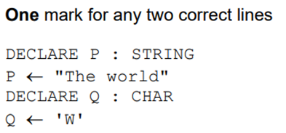  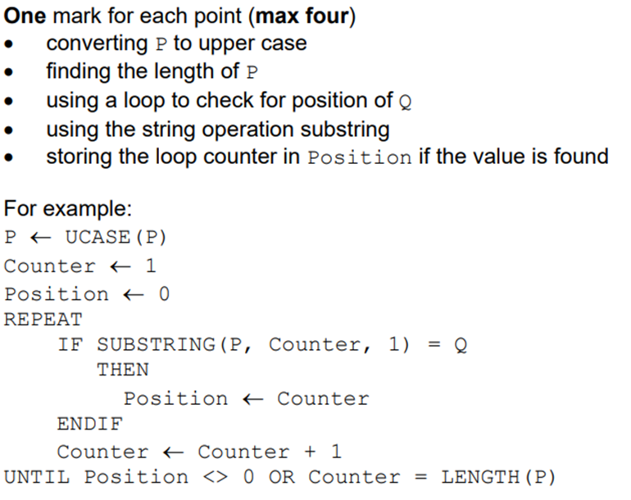 [6]

