Revision- Programming
1. A function is declared using pseudocode
FUNCTION ConvertToCm (Inches: REAL) RETURNS REAL
RETURN Inches * 2.4
ENDFUNCTION

Choose the correct answer which accurately describes the use of variable Inches
- Answer
- Call
- Parameter
- response

……………………………………………………………………………………… [1]

2. Draw a line to link each pseudocode description to the most appropriate pseudocode statement.
Some pseudocode statements will not be used.
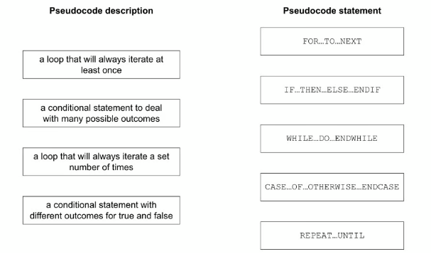 [4]
3. The variables X, Y and Z are used to store data in a program:
- X stores a string
- Y stores a position in the string
- Z stores the number of characters in the string.
- Write pseudocode statements to declare the variables X, Y and Z.
……………………………………………………………………………………….
……………………………………………………………………………………….
……………………………………………………………………………………….. [3]
4. Name and describe the most appropriate programming data type for each of the examples of data given. Each data type must be different.
Data: 37
Data type name ............................................................................
Data type description ..................................................................
Data: Cambridge2021
Data type name .............................................................................
Data type description ...................................................................
Data: 47.86
Data type name .............................................................................
Data type description ................................................................... [6]
5. Task 1 – Setting up the voting system to allow a tutor group to elect a representative. Write a program to:
- allow the tutor to enter the name of the tutor group
- allow the tutor to enter the number of students in the tutor group
- allow the tutor to enter the number of candidates in the election; maximum of four candidates
- allow the tutor to enter the names of the candidates and store them in a suitable data structure
- allow each student to input their vote or to abstain

When all students have voted, display the name of the tutor group, the votes for each candidate and the name of the candidate who has won the election. If there is a tie for first place, display all candidates with the equal highest number of votes.
a)All variables, constants and other identifiers must have meaningful names.
i) Identify one constant you could have used for Task 1, give the value that would be assigned to it and its use.
Constant .........................................................
Value ................................................................
Use .................................................................... [3]
ii) Identify one variable and one array you could have used for Task 1.
Explain the use of each one.
Variable ..........................................................
Use ................................................................... [2]
6. The variables P and Q are used to store data in a program. P stores a string and Q stores a character.
(a) Write pseudo code statements to declare the variables P and Q, store “The world” in P and store ‘W’ in Q.
……………………………………………………………………………………………………………
……………………………………………………………………………………………………………
……………………………………………………………………………………………………………
…………………………………………………………………………………………………………… [2]
(b) Write pseudocode algorithm to:
- Convert P to uppercase
- Find the position of Q in the string P (The first character in this string is in position 1)

- Store the position of Q in the variable position.

……………………………………………………………………………………………………………
……………………………………………………………………………………………………………
……………………………………………………………………………………………………………
……………………………………………………………………………………………………………
……………………………………………………………………………………………………………
……………………………………………………………………………………………………………
……………………………………………………………………………………………………………
……………………………………………………………………………………………………………
…………………………………………………………………………………………………………… [4]

