1. The cumulative frequency step polygon shows information about the numbers of students in the 48 teaching sets in Year 12 at Pearson Academy.

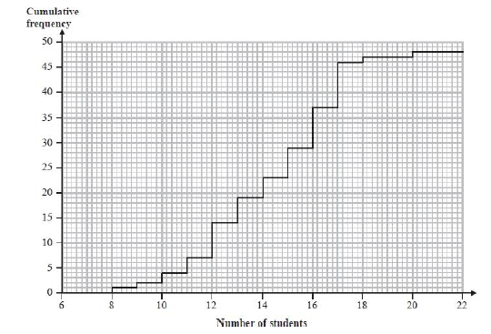

For the numbers of students in the teaching sets, find

(i) the median,

(ii) the interquartile range,

1. The table shows information about the time taken, in minutes, by each of the Wimbledon men's singles final matches for the 30 years from 1985. Explain why the class interval which contains the median time taken is 160 ≤ *t* < 200

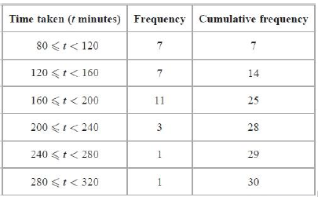

b) Draw cumulative frequency diagram of the above-mentioned data.

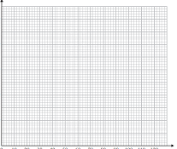

1. The cumulative frequency diagram shows the distribution of ages of a sample of 100 teachers in the UK.

Complete this table for the ages of these 100 teachers.

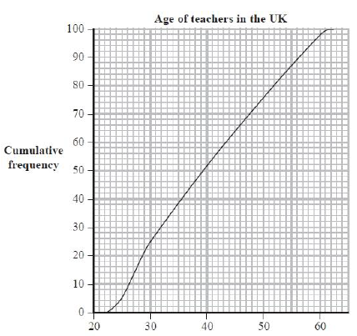

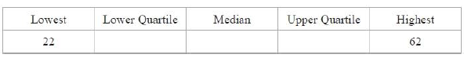

1. $c$ is inversely proportional to $d^{2}$. Given that $c=12.5$ when $d=4$.
   1. Find the formula connecting $c$& $d$.
   2. Use this formula to find $c$ when $d=10$
   3. Use your formula to find $d$ when $c=8$
2. A ball falls d metres in t seconds. d is directly proportional to the square of t. The ball falls 44.1m in 3 seconds.

## Find a formula for d in terms of t

* 1. Calculate the distance the ball falls in 2 seconds.

1. The diagram shows the speed—time graph for the first 120 seconds of a car journey.

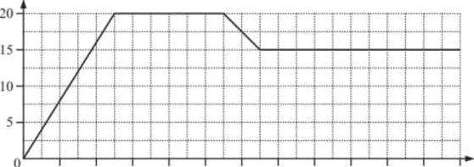

* + - * + Calculate the acceleration of the car during the first 25 seconds.
* Calculate the distance travelled by the car.

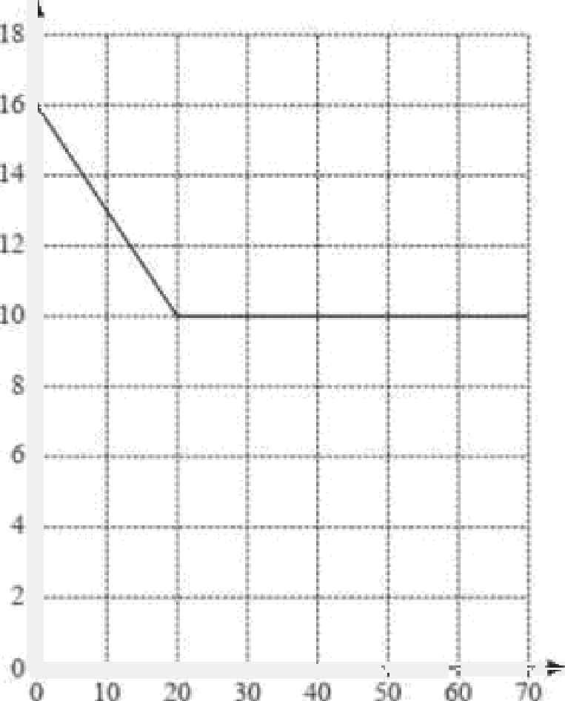

* + 1. Calculate the deceleration of the car during the first 20 seconds.
    2. Calculate the total distance travelled by the car during the 70 seconds.