The menstrual cycle

The graph shows the concentration of two hormones during a woman’s menstrual cycle.

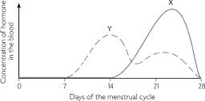

1 Name hormones X and Y.

Hormone X ………………………………………………………………………………

Hormone Y ……………………………………………………………………………… [1]

2 Where are these two hormones produced?

.……………………………………………………………………………………………………………………………………………………………………….. [1]

3 Describe what is happening in the uterus during

days 1 to 5

………………………………………………………………………………………………………………………………………………….………………………….

……………………………………………………………………………………………………………………………………….……………………………………..days 8 to 14

………………………………………………………………………………………………………………………………………………….………………………….

……………………………………………………………………………………………………………………………………….…………………………………… [1]

4 On the graph, indicate the time you would expect ovulation to happen. ………………………………… [1]

5 Describe what happens at ovulation.

………………………………………………………………………………………………………………………………………………….………………………….

……………………………………………………………………………………………………………………………………….……………………………… [1]

© Cambridge University Press 2014 IGCSE® Biology Worksheet 17.1