1. 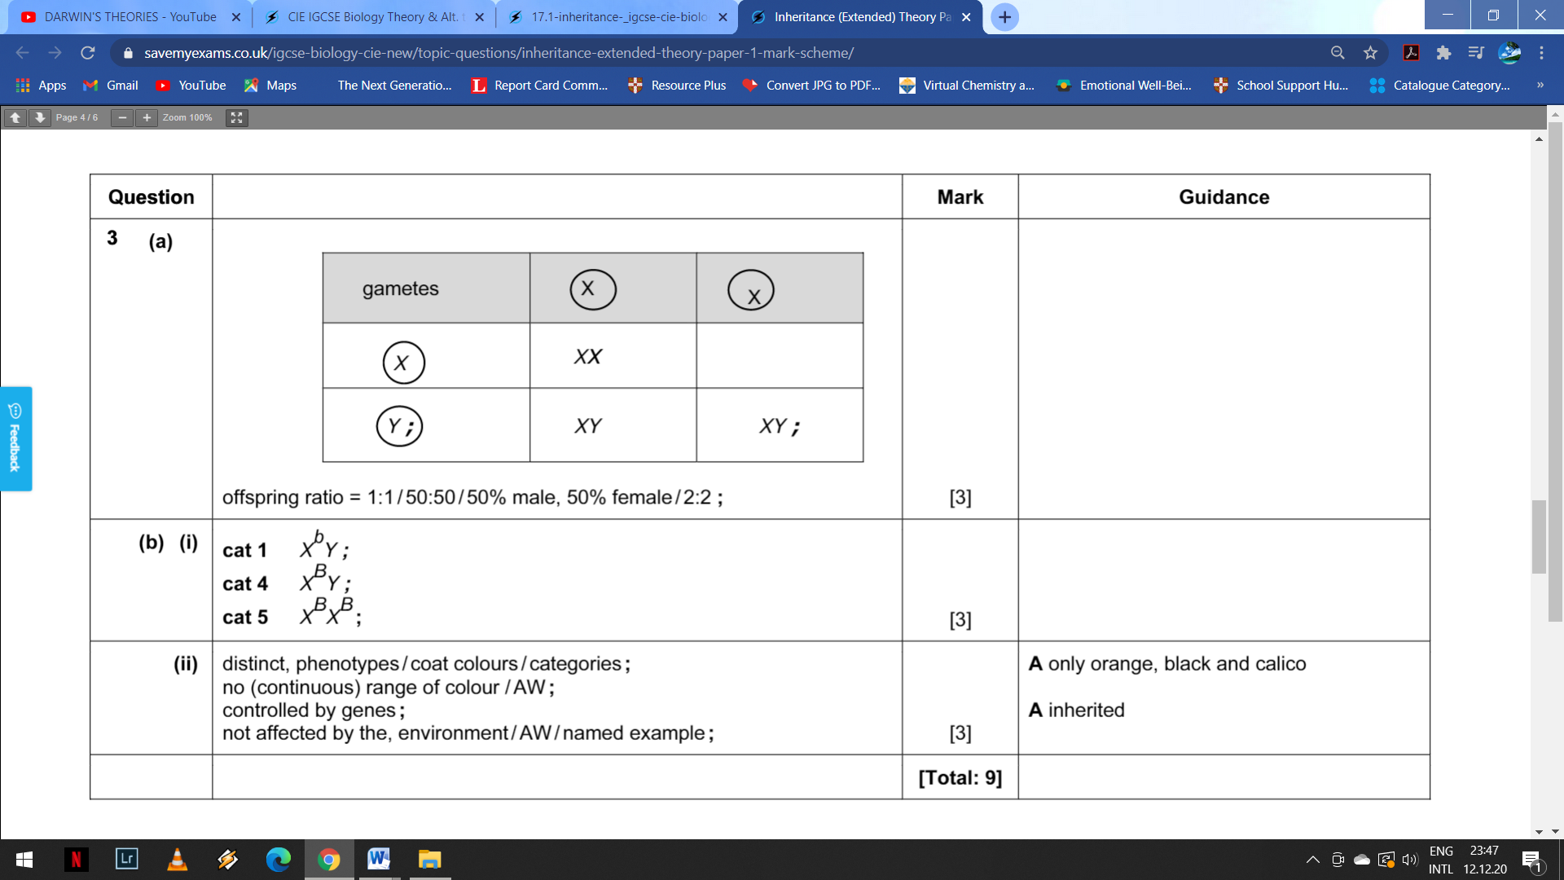
2. Check page 327 (18.15) of coursebook.