### What is the name given to copies of data or program files?

 A) Backups

 B) Programs

 C) Extras

 D) Stores

### Which of the following is an example of a backing storage device?

 A) Speaker

 B) Mouse

 C) Hard Disk Drive

 D) RAM

### Hard Disk Drives are a form of what type of storage?

 A) Optical

 B) Solid State

 C) Magnetic

 D) Sequential

### Blu-Ray discs are a form of what type of storage?

 A) Solid State

 B) Magnetic

 C) Sequential

 D) Optical

### Flash Memory Sticks are a form of what type of storage?

 A) Optical

 B) Solid State

 C) Magnetic

 D) Sequential

### Serial data access is faster than direct data access?

 A) True

 B) False

### Tick the boxes of the storage media you think use direct access

 Magnetic Hard Disk

 Flash Memory Stick

 Magnetic Tape

 DVD Disc

### Read the following statements and then select if they are True or False

CD-ROMS can record data over and over again --  True -  False

Fixed hard disks can be described as portable --  True -  False

Magnetic tape storage media uses serial data access --  True -  False

DVD-R discs can store more than CD-R discs --  True -  False

Floppy discs can store huge amounts of data --  True -  False

### Name the following images using the options provided

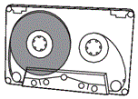 -  Pen Drive -  Magnetic Tape -  DVD-RAM -  Fixed Hard Disk

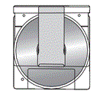 -  Pen Drive -  Magnetic Tape -  DVD-RAM -  Fixed Hard Disk

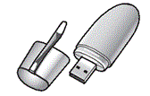

 Pen Drive -  Magnetic Tape -  DVD-RAM -  Fixed Hard Disk

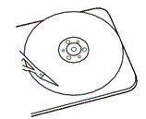 -  Pen Drive -  Magnetic Tape -  DVD-RAM -  Fixed Hard Disk

### What is the order of capacity (smallest to largest) of the following storage media?

 A) Fixed Hard Disk -- Blu-ray -- DVD -- Floppy Disk

 B) Floppy Disk -- Blu-ray -- DVD -- Fixed Hard Disk

 C) DVD -- Floppy Disk -- Blu-ray -- Fixed Hard Disk

 D) Floppy Disk -- DVD -- Blu-ray -- Fixed Hard Disk