

1. Input-process-output model is used in many systems. Printing system is one of the example of input-process-model system.

Write down the correct description for input process and output of a printing system. **[3]**

**INPUT 🡪 PROCESS 🡪 OUTPUT**

1. Smart devices are all around us, from smart city concept to smart home concept.

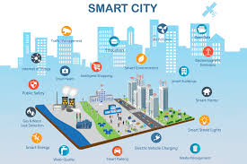Name any three smart devices and explain any one of them. **[5]**

________________________________________

_________________________________________

_________________________________________

_________________________________________

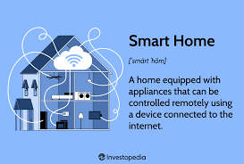_________________________________________

_________________________________________

_________________________________________

_________________________________________

_________________________________________

_________________________________________

_____________________________________________________________________

_____________________________________________________________________

_____________________________________________________________________

_____________________________________________________________________

1. Artificial intelligence is a reality now a days and we see around many objects that are based on AI systems.

a) Write down any three things that contain artificial intelligence in it. **[3]**

1. _________________________________________
2. _________________________________________
3. _________________________________________

b) Explain how Predictive text works in word processor software? **[2]**

_____________________________________________________________________

_____________________________________________________________________

_____________________________________________________________________

_____________________________________________________________________

_____________________________________________________________________

1. Imagine you are designing an autonomous vehicle that does not need a driver to detect and avoid bumping into things.

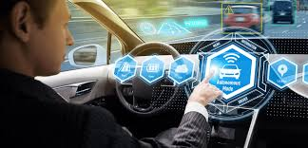

Draw a simple program to show and describe the input-process-output model for the car. **[3]**

1. Choose the right option for the given blanks. **[4]**
2. Input can be describe as
3. Anything that is put into a system
4. The steps or actions taken by the system using the input
5. The result of the process
6. Smart lock systems can be used to?
7. Secures hotel doors
8. Controls, smart sprinkle system
9. Assist in surgeries
10. Autonomous means ___________.
11. Cannot function by its own
12. Can functions by its own
13. Needs human to operate them
14. A ___________ is an input in audio production.
15. Speaker
16. Microphone
17. Music