**QUIZ 8**

Chapter 3 (GRADED)

1. Complete the table by identifying the most appropriate storage method for each type of application.

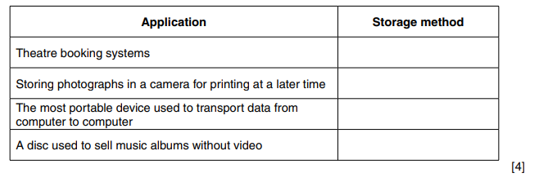

1. Tick whether the following statements about internal and external memory are true or false.

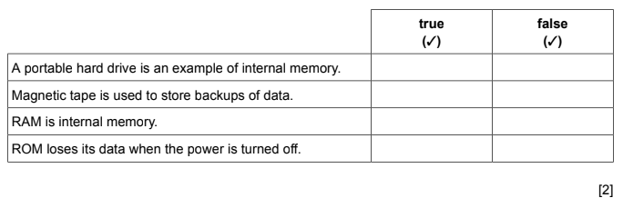

1. Laptop computers are often equipped with Solid State Drives (SSD) or Hard Disk Drives (HDD).

Give **four** advantages of SSD compared to HDD.

1……………………………………………………………………………………………………………………………………………………….………………………………………………………………………………………

2……………………………………………………………………………………………………………………………………………………….………………………………………………………………………………………

3……………………………………………………………………………………………………………………………………………………….…………………………………………………………………………………........4…………………………………………………………………………………………………………………………………………………………………………………………………………………………………………… [4]