MS-WORD

Microsoft Word is a word processor developed by Microsoft. It was first

released in 1983 under the name Multi-Tool Word for Xenix systems. MS

Word is a popular word-processing program used primarily for creating

documents such as letters, brochures, learning activities, tests, quizzes and

students' homework assignments. There are many simple but useful features

available in Microsoft Word to make it easier for study and work. That's why

so many people would prefer to convert the read-only PDF to editable Word

and edit PDF in Word.

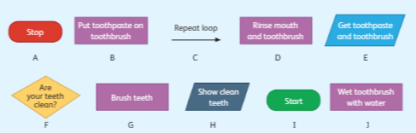Task 1- Create a flowchart by putting the flowchart symbols in right order from the given algorithm using MS Word. [10]

1.Open the MS Word. /1

2.Rearrange them in the right order using the flow chart symbols. /7

3.Use the arrows to show the flow of the algorithm. /1

4. Save the flowchart Yourname-Task1. /1

|  |  |  |  |  |
| --- | --- | --- | --- | --- |
| **Rubric for flowchart** | | | | |
|  | 1 | 2 | 3 | Total |
| Able to use the flow chart symbols |  |  |  |  |
| Able to sort the algorithm |  |  |  |  |
| Able to save |  |  |  |  |
| **Key**:1. Needs more opportunity to develop this skill.  2.Beginning to demonstrate this skill.  3.Has achieved this skill. | | | | |

Task 2 -Create a spreadsheet and use the “Find” feature.

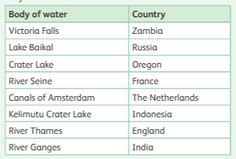

1. Enter the above data in spreadsheet. /1

2. Use the find feature to find the following; /6

a) Find how many lakes are there?

______________________________________________________

b) Find and write down the cell address of the Crater lake?

________________________________________________________

c) Use the phrase “River” and find how many rivers are there as a body water?

__________________________________________________________

|  |  |  |  |  |
| --- | --- | --- | --- | --- |
| **Rubric for Spreadsheet** | | | | |
|  | 1 | 2 | 3 | Total |
| Able to enter data |  |  |  |  |
| Able to use find feature |  |  |  |  |
| Able to identify cell address |  |  |  |  |
| **Key**:1. Needs more opportunity to develop this skill.  2.Beginning to demonstrate this skill.  3.Has achieved this skill. | | | | |