Purpose | 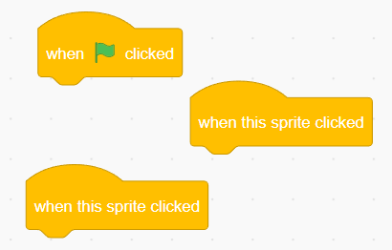
Events | This program is for one character to do the addition between the given numbers
Expected output | 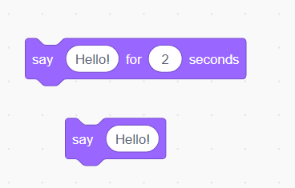
Term 1  Session 2024-2025 |  | Name: _______________  Date: _______________

Extension Task
Match the following with the correct option:

