Analyse the following enlarging and find scale factor of each transformation
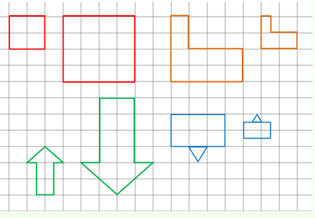

1

2

3

4

