Duration: 10 min Total score: 10

- Describe fully the single transformation that maps shape A onto shape B (2)
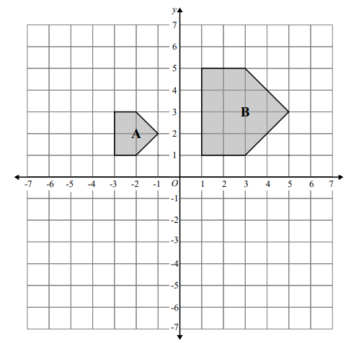

…………………………………………………………………………….

…………………………………………………………………………..

- Enlarge the shaded triangle by scale factor 2, centre (1, 0) (3)
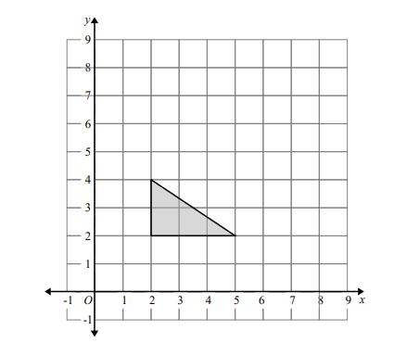

- Enlarge the shaded triangle by scale factor 1.5, centre O. (3)
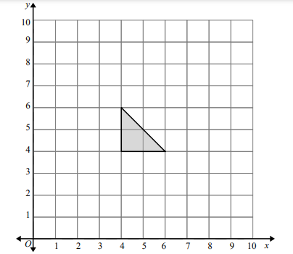

- Give the coordinates of the centre of enlargement and find the scale factor that give the following images of the shaded objects. (2)

