- Enlarge triangle ABC by scale factor 2, using the point P as the centre of enlargement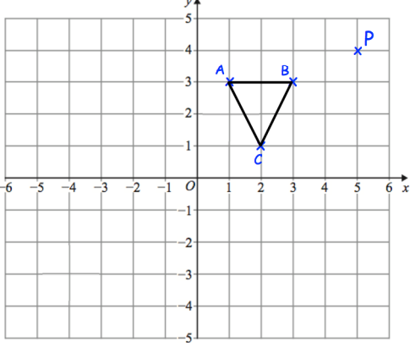

- Enlarge the trapezium by scale factor 3, centre (6, 0).
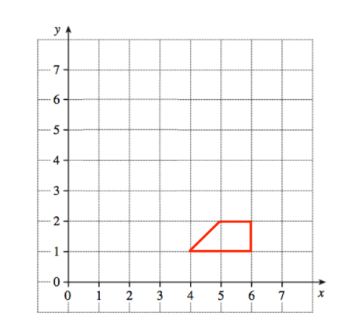

- Rectangle E is an enlargement of rectangle D on the centimetre grid
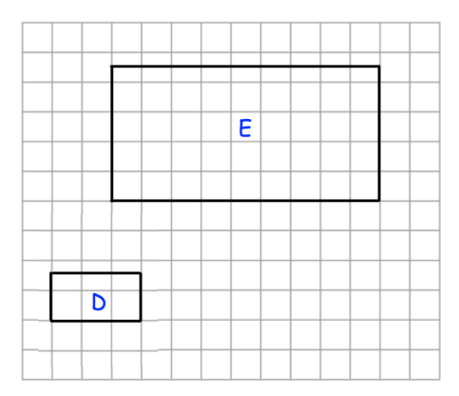
- What is the scale factor of the enlargement?

Rectangle E is enlarged by scale factor 20 to give rectangle F.
(b) Write down the length and width of rectangle F.

- Enlarge triangle A by scale factor 2, using centre of enlargement (5, −5)
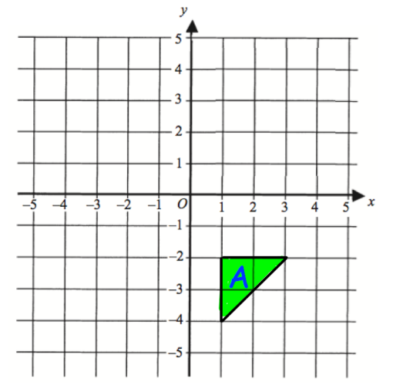

- Describe fully the single transformation that maps shape A onto shape B








