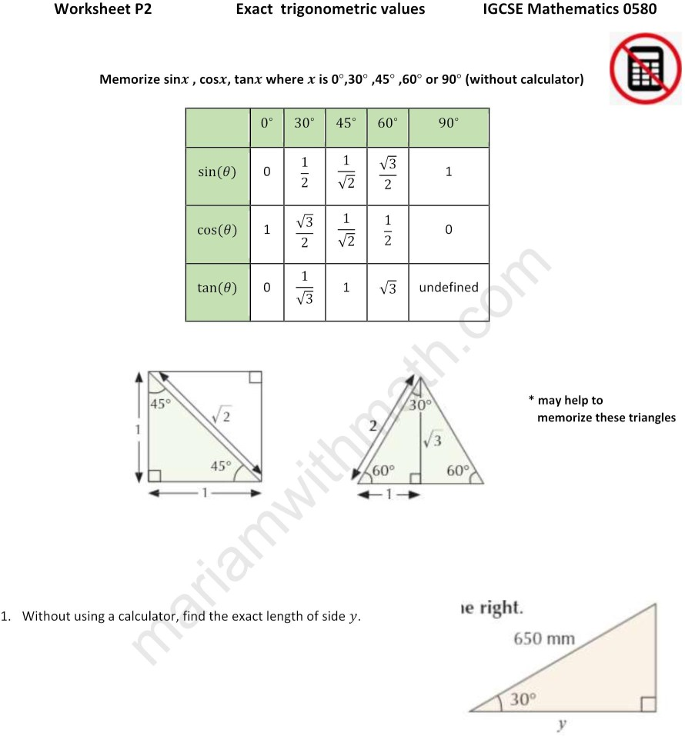

1. Write down the exact value of Cos 60°
2. Write down the exact value of Sin 30°
3. Write down the exact value of Tan 0°

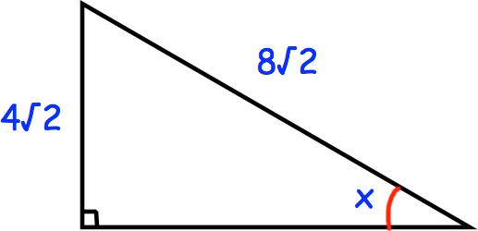

Show that angle x = 30° Include all your working.

1. Find the exact length of the side labelled y.

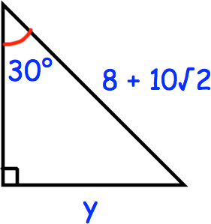

1. 