**PRACTICAL WORKSHEET**

1. Open a word processing document.
2. Place in the header your name, centre number and candidate number, centre-aligned. [1]
3. Place in the footer automated page numbers, right-aligned. [1]
4. Make sure that:

• all the alignments match the page margins

• no other text or placeholders are included in the header and footer areas

• headers and footers are displayed on all pages.

1. At the start of the document enter the title:

**Tawara MTB Marathon Race**  [1]

1. Create the table :

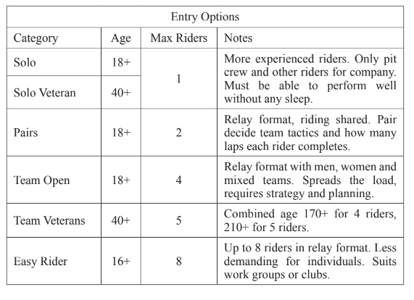[4]

1. Format only the first row of the table so it:

• has a white 14 point sans-serif font

• is bold and italic

• has a black background. [3]

1. Make sure:

• the table borders and all data fit within the column width

• no words are split where text is wrapped in column 4

[2]