Task 1)

|  |  |  |  |
| --- | --- | --- | --- |
| **RUBRIC FOR SCRATCH PROGRAM.** | | | |
|  | 1 | 2 | 3 |
| Able to create a variable |  |  |  |
| Able to add backdrop |  |  |  |
| Able to add sprite |  |  |  |
| Able to create a code |  |  |  |
| **Key**:   1. Needs more opportunity to develop this skill. 2. Beginning to demonstrate this skill. 3. Has achieved this skill. | | | |

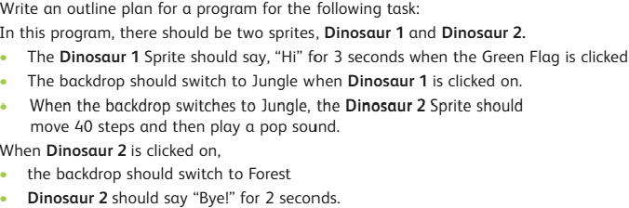Task 2)

_______________________________________________________________________________________________________________________________________________________________________________________________________________________________________________________________________________________________________________________________________________________________________________________________________________________________________________________________________________________________________________________________________________________________________________________________________________________________________________________________________________________________________________________________________________________________________________________________________________________________________________________________________________________________________________