Term: 2

Session: 2023

–

2024

Name: _______________

Date:

______________



# Surah Kawther

|  |  |  |  |  |  |
| --- | --- | --- | --- | --- | --- |
| Recitation    1 | Memorization    2 | Articulation points  3 | Implementation of Tajweed  2 | Fluency    2 | Total Marks    10 |
|  |  |  |  |  |  |

# Rabbana Dua

|  |  |  |  |  |  |
| --- | --- | --- | --- | --- | --- |
| Recitation    1 | Memorization    1 | Articulation points  1 | Implementation of Tajweed  1 | Fluency    1 | Total Marks    5 |
|  |  |  |  |  |  |

Term: II

Session: 2023

–

2024

Name: _______________

Date:

______________



# Qaida lesson 5

|  |  |  |  |
| --- | --- | --- | --- |
| Articulation point    2 | Implementation of  Tajweed  2 | Fluency    1 | Total Marks    5 |
|  |  |  |  |

* 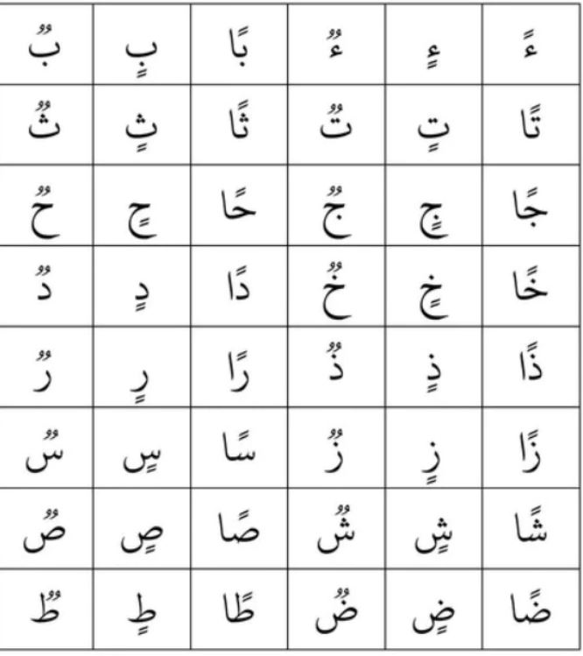How many heavy letters are there? Write any three.

(5 marks)

* How do you pronounce it marks?

1. Lightly b) Full mouth