1. 44 tins of soup have a mass of 1.81.8kg. 33 tins of soup and 22 packets of soup have a mass of 1420 g.  Find the mass of 77 tins of soup and 55 packets of soup. Give your answer in kilograms.
2. A bottle contains 1.751.75 liters of lemonade. A can contains 330 ml of lemonade. Phil has 22 bottles of lemonade and 66 cans of lemonade. How much lemonade does he have in total?

Give your answer in milliliters.

1. Here is a signpost

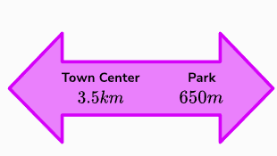

How far apart are the Town Centre and the Park? Give your answer in kilometers.

1. In the garden there is an area that needs covering with bark chippings. The area is 2.210 000 cm2. A bag of bark chippings covers 2.4 m2. How many bags of bark chippings are needed to be bought to cover the area?