Types of Organisations

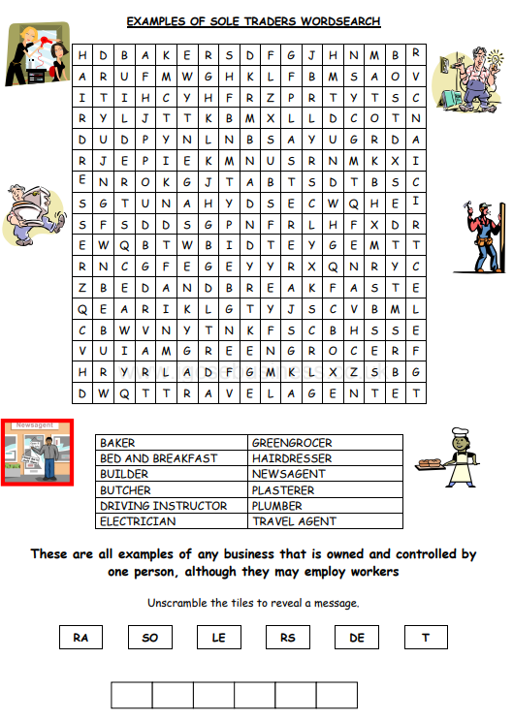Starter Activity:

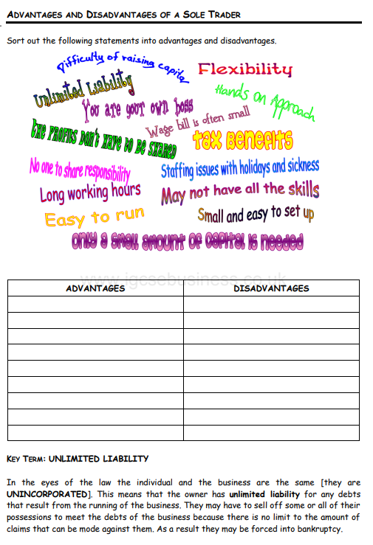Identify Advantages and Disadvantages of the Sole Trader

Case Study:

George Sanders was employed by a national newspaper but was made redundant in January 2003. He spent seven months searching for another reporting job, but eventually gave up and decided to set up his own business. He had always enjoyed books and opened up a second-hand bookshop in Cardiff. In a room above the bookshop, he opened up a small café. He used £4,000 of his savings and a £1,000 bank loan to meet the set-up costs. He also qualified for £40 per week from the government’s Enterprise Allowance Scheme. George employed two part-time students to help out in the café during weekends and school holidays. After a slow start business picked up and his café gained popularity with students from three local colleges. He spotted an opportunity and lowered prices slightly to encourage even more students to visit.

After one year he extended his bank loan to £2,000 and bought some more kitchen equipment to provide substantial lunchtime meals. Again, he kept prices low and targeted the student market. The business expanded and George was beginning to enjoy good profits. The bookshop only made a small contribution to turnover, but George felt that it helped the image of the café which attracted his customers.

One morning when he was opening, a local authority representative arrived unannounced to inspect the business premises. After a two-hour investigation, the inspector left saying that George would hear from the authorities the next day. A letter from them informed George that his kitchen must conform to a long list of health regulations. George estimated that the cost would be £3,000. He arranged a meeting with the bank that same afternoon. Unfortunately, they could only lend him half the amount. George was eventually forced to borrow from a private loan company, paying high rates of interest.

1. What features of a sole trader does the example of George Saunders’ business show?

………………………………………………………………………………………………………………………………………………

………………………………………………………………………………………………………………………………………………

………………………………………………………………………………………………………………………………………………

………………………………………………………………………………………………………………………………………………

………………………………………………………………………………………………………………………………………………

1. In what way does the above case highlight the advantages and disadvantages of being a sole trader?

Advantages:

………………………………………………………………………………………………………………………………………………

………………………………………………………………………………………………………………………………………………

………………………………………………………………………………………………………………………………………………

………………………………………………………………………………………………………………………………………………

Disadvantages:

………………………………………………………………………………………………………………………………………………

………………………………………………………………………………………………………………………………………………

………………………………………………………………………………………………………………………………………………

………………………………………………………………………………………………………………………………………………