# Encircle the correct answer. /2

* 1. Which of the network devices are found in home?

|  |  |
| --- | --- |
| a) scanner  Epson Perfection V600 Photo Scanner | Products | Epson US | b) multifunction machines  Canon Multifunction Copier Machines - Canon IR2630 Multi Function Copier  Retailer from Chennai |
| c) gaming console  Buy MSI Claw A1M Handheld Gaming Console in Qatar - AlaneesQatar.Qa | d) tablets  The 5 Best Tablets for 2024 | Reviews by Wirecutter |

* 1. A program written to cause damage to data and software is called

|  |  |
| --- | --- |
| a) backup | b) computer virus |
| c) services | d) world wide web |

* 1. The shown block means:

|  |  |
| --- | --- |
| a) changes the size of the sprite. | b) causes the sprite to wait or pause for a number of seconds. |
| c) moves a sprite up or down. | d) move forward. |

* 1. To get a result using the least amount of time or steps is called

|  |  |
| --- | --- |
| a) concise | b) algorithm |
| c) efficient | d) edit |

# Write (true) if the sentence is correct and (false) if it is not. /5

1. In scratch, reset means to return to the original state. ______________
2. An algorithm is a set of instructions. The steps of algorithm must be in the right order.

______________

1. A home network provides more services than a school network. ______________
2. Someone needs to make sure the network keeps running properly. ___________
3. An e – reader is a device that can be a part of home network. _____________

10) Hardware, such as printers, photocopiers and scanners cannot be shared on a

network. ______________

11) Communication services are available in networks in homes and schools. ______________

12) Security measures are needed to protect a network from viruses. ______________

13) Gaming consoles are usually found in school network. ______________

14) Sharing files is not possible on a network. ______________

# Fill in the blanks with the help of the words given in the box. /2.5

|  |  |  |  |  |
| --- | --- | --- | --- | --- |
| Network | Smart devices | Efficient | Backup | expensive |

15) The best algorithms are ________________________. This means they carry out a

task using the least number of steps.

16) Some homes may also have ________________________ such as refrigerators,

light bulbs and heaters.

17) A broken ____________________ can stop users from accessing services.

18) It is easy to make a ___________________ copy of data and files.

19) Keeping a network safe is _____________________________.

1. **Write two services available on home and school network.**  **/2**

|  |  |
| --- | --- |
| **Home network** | **School network** |
|  |  |
|  |  |

**V. Circle the devices that can be found in a school network. /2**

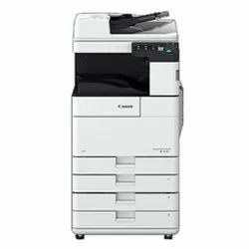

**VI. a.** **Pattern recognition. /1.5**

Judy is picking some flowers for her mom. Here is the algorithm for Judy to pick the flowers.

Are there any steps that can be combined to make Algorithm A shorter?

Copy and complete Algorithm B so that it does the same as Algorithm A.

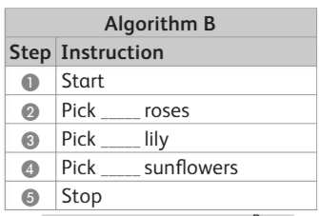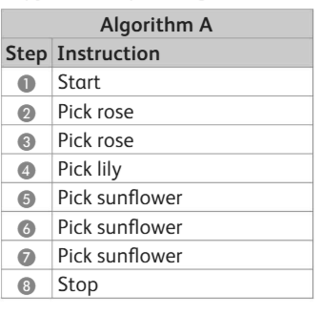

**b. This is the code for a tree to grow in the forest. /5**

i. Identify and circle the blocks of code that are repeated.

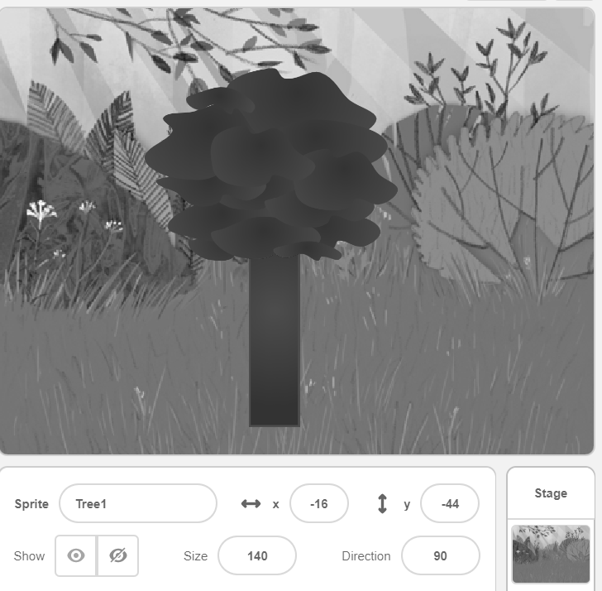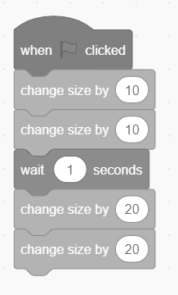

ii. Which blocks of code could replace the first two "Change size by 10" blocks in the

program?



______________________________

iii. Which blocks of code could replace the last two "Change size by 20" blocks in the

program?



______________________________



iv. How many blocks are there in this program?

_________________________

v. How many blocks are there in the new program?



