Marketing Mix: product
The product life cycle
Starter activity:
Key terms | Definition
Product life cycle
extension strategies

Development activity:
State the four stages of the product life cycle. Draw and annotate these stages in the form of a diagram using the example of product life cycle of a fashion clothing vs a hi-tech product.
……………………………………………………………………………………………………………………………………………………………….
……………………………………………………………………………………………………………………………………………………………….
……………………………………………………………………………………………………………………………………………………………….
……………………………………………………………………………………………………………………………………………………………….
……………………………………………………………………………………………………………………………………………………………….
……………………………………………………………………………………………………………………………………………………………….
……………………………………………………………………………………………………………………………………………………………….
……………………………………………………………………………………………………………………………………………………………….
……………………………………………………………………………………………………………………………………………………………….
……………………………………………………………………………………………………………………………………………………………….
……………………………………………………………………………………………………………………………………………………………….

Support notes:
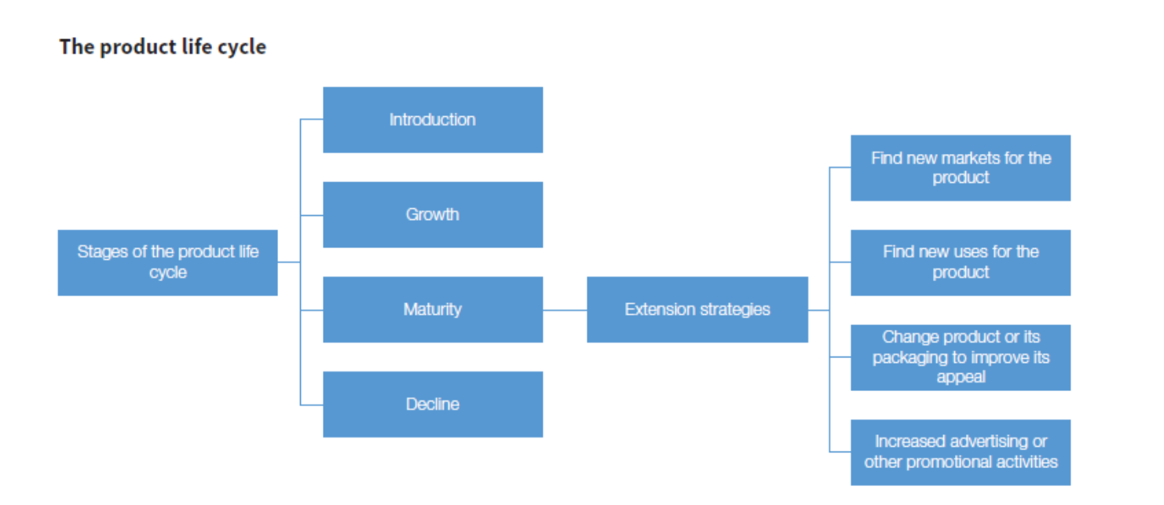

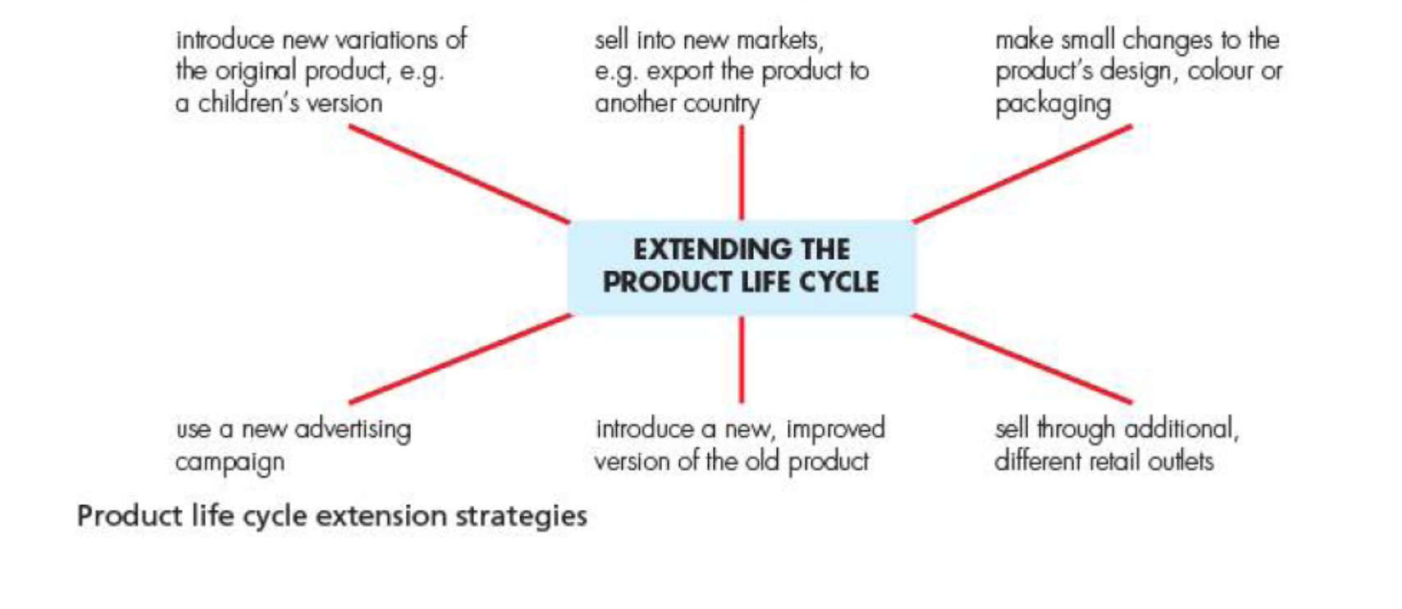

Practice Activity:













